**BỘ GIÁO DỤC VÀ ĐÀO TẠO**

**TRƯỜNG ĐẠI HỌC KHOA HỌC TỰ NHIÊN – ĐHQG TPHCM**



**REPORT**

***Course: Programming Techniques – CSC10003***

**Project:**

**COURSE MANAGEMENT SYSTEM**

**Lecturers:**

Đinh Bá Tiến

Trương Phước Lộc

Đỗ Nguyên Kha

**THÀNH PHỐ HỒ CHÍ MINH, 2023**

**TEAM 3**

REPORT PROJECT

|  |  |  |  |
| --- | --- | --- | --- |
| **No** | **ID** | **Last name** | **First name** |
| 1 | 22127026 | Ôn Gia | Bảo |
| 2 | 22127123 | Lê Hồ Phi | Hoàng |
| 3 | 22127275 | Trần Anh | Minh |
| 4 | 22127402 | Bế Lã Anh | Thư |

**Contents**

**1.** **The goal of the group:** 3

**2.** **Implementation plan** 3

**3.** **Description of Structures Used** 3

**A.** **Libraries:** 3

**B.** **Struct:** 4

**C.** **Main components** 11

**i.** **[All] Section** 11

**ii.** **[Sem] Section** 52

**iii.** **[Sem] Year** 83

**iv.** **[Help] Section** 93

**v.** **[Course] Section** 101

**vi.** **[Class] Section** 115

**vii.** **[Student] Section** 120

**viii.** **Login.cpp** 125

**ix.** **Main.cpp** 131

**4.** **Summary** 131

1. **The goal of the group:**

The main goal our team is to provide a comprehensive and efficient online platform for universities to manage their course offerings. The system aims to streamline the administrative process and enhance communication between lecturers and students. It will allow lecturers to upload course materials, assignments, and grades while providing students with easy access to course information and resources. The system also aims to improve student-teacher interaction while enabling universities to monitor academic progress and performance. Ultimately, the goal is to create a platform that enhances the overall learning experience and contributes to academic success.

1. **Implementation plan**

Main programming language: C/C++

Main working environment: GitHub

Software for discussion: Messenger, Google Meet

Workflow: Each team member is allocated particular duties that contribute to the completion of the project. These tasks need to be fulfilled and uploaded to GitHub on a weekly basis. It is within the team's guidelines for members to assist each other in completing their tasks. However, members need to be accountable for their own contributions. In case of coding errors or mishaps, the individual who made the final edit will need to take responsibility.

Task assignment table:

|  |  |  |  |  |
| --- | --- | --- | --- | --- |
| **No** | **ID** | **Last name** | **First name** | **Task assignment** |
| 1 | 22127026 | Ôn Gia | Bảo | Task 14, 15, 16, 17, 18, 24, files .csv, write report |
| 2 | 22127123 | Lê Hồ Phi | Hoàng | Task 19, 20, 21, 22, 23, merge code, write report |
| 3 | 22127275 | Trần Anh | Minh | Task 6, 7, 8, 9, 10, 11, 12, 13, merge code, UI, write code |
| 4 | 22127402 | Bế Lã Anh | Thư | Task 1, 2, 3, 4, 5 |

1. **Description of Structures Used**
2. **Libraries:**

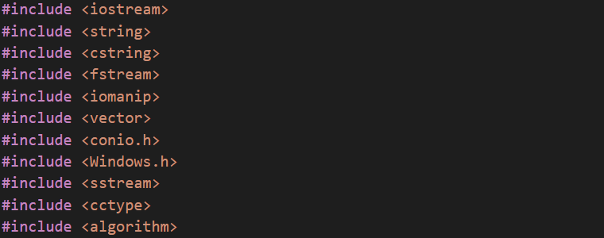

1. **Struct:**

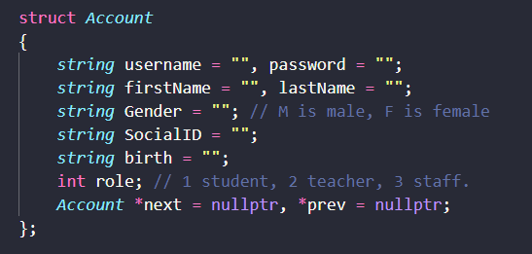

The Account struct is designed to represent user accounts in the management system. It contains the following member variables:

* username: a string representing the username of the account.
* password: a string representing the password of the account.
* firstName: a string representing the first name of the account holder.
* lastName: a string representing the last name of the account holder.
* Gender: a string representing the gender of the account holder (M for male, F for female).
* SocialID: a string representing the social ID of the account holder.
* birth: a string representing the date of birth of the account holder (DD/MM/YYYY).
* role: an integer representing the role of the account holder (1 is student, 2 is teacher, 3 is staff).
* next: a pointer to the next Account struct in a linked list of accounts.
* prev: a pointer to the previous Account struct in a linked list of accounts.

The Account struct provides a centralized and structured way to manage and authenticate user information, ensuring secure access and appropriate permissions to different resources within the course-management system.

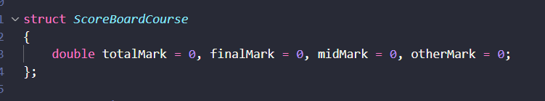

The ScoreBoardCourse struct is used in a course-management system to store and manage the marks of a student in different assessments, including the final exam, mid-term exam, and other assignments. The struct has four double-type variables, including totalMark, finalMark, midMark, and otherMark. The totalMark variable stores the overall mark of the student in the course, whereas the finalMark, midMark, and otherMark variables store the marks obtained by the student in the final exam, mid-term exam, and other assessments, respectively.

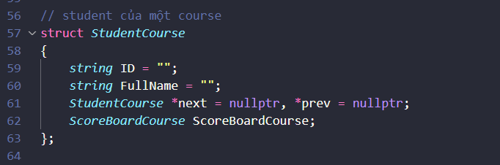

The StudentCourse struct is designed to represent an student in a course.

* ID: a string represent the ID of the student
* FullName: a string represent the student’s full name
* next: a pointer to the next StudentCourse in a linked list of students in a course
* prev: a pointer to the prev StudentCourse in a linked list of student in a course
* ScoreBoardCourse: store score board of a student in a course

By using a linked list to connect each StudentCourse object, it allows for efficient traversal and manipulation of the data structure. The inclusion of the ScoreBoardCourse object also allows for the storage and calculation of relevant course metrics, such as average scores and grading information. Overall, this struct plays a crucial role in organizing and managing student and course data within an education system.

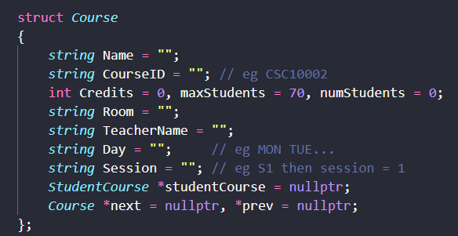

The Course struct is designed to represent a course in a semester.

* Name: a string that represents the name of the course.
* courseID: a string that uniquely identifies a course in the university's course catalog (eg CSC10002).
* Credits - an integer value that represents the number of credits for the course.
* maxStudents - an integer value that represents the maximum number of students that can be enrolled in the course.
* numStudents - an integer value that represents the number of students who are currently enrolled in the course.
* Room: a string that represents where the course take place (eg I62).
* teacherName - a string that represents the name of the teacher who is teaching the course.
* Day: a string that represents the day of the week on which the course is scheduled (eg MON, TUE, …).
* Session: a string that represents the time period during which the course is scheduled (eg S1 then session = 1)
* studentCourse: a pointer to the first student in the linked list of enrolled students.
* next: a pointer to the next course in the linked list of courses.
* prev: a pointer to the prev course in the linked list of courses.

The "Course" structure is a key element of software that manages student records in an academic institution, holding specific details about a course including the course name, ID, teacher name, session, credits, day of the week, and a roster of enrolled students.

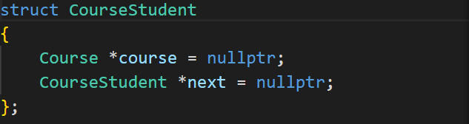

This CourseStudent struct represents a node in a linked list of courses that a student is enrolled in.

* course: a pointer to a course of that student.
* next: a pointer to the next CourseStudent node in a linked list, which is the next course of that student.

This linked list structure is useful for storing and maintaining a list of course that a student is enrolled in, allowing for easy iteration and modification of this list as needed.

Overall, the CourseStudent struct is a simple but effective way to represent the relationship between courses and enrolled students in the course management system.

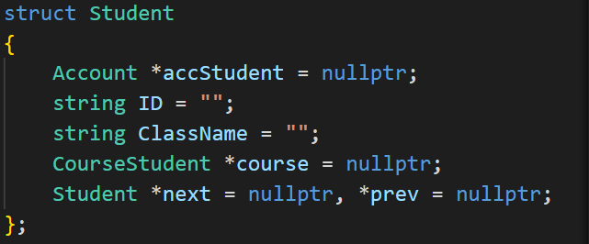

The 'Student' struct serves as a representation of a real-life student in the context of a university and stored in a specific class. It is comprised of the following components:

* accStudent: This pointer stores the address of the student's account. The account stores the student's username, password, and other essential details for authentication and personalization in the system.
* ID: a string represents the student's identification number, which helps distinguish each student from one another and acts as a unique identifier in the system. It allows the software to quickly access, search, and update information pertaining to individual students.
* ClassName: a string that represents the class name that the student belongs to.
* course: a pointer to the CourseStudent structure, which comprises the courses the student has enrolled in during the semester. It enables management of a student's curriculum, including the updating and accessing of course details.
* Student *next, *prev: two pointers to the adjacent Student structs in a double-linked list. 'next' is a pointer to the subsequent student, while 'prev' is a pointer to the preceding student on the list of students in a specific class. This facilitates navigating the student list and performing various actions related to student data storage and organization.

The 'Student' struct is a well-designed structure that efficiently represents students within the course management system software. It facilitates streamlined data storage, organization, and management and ensures scalability and flexibility within the system. This struct plays a significant role in the overall performance of the software, contributing to its success in managing the educational work of teachers and enabling students to control their studies effectively.

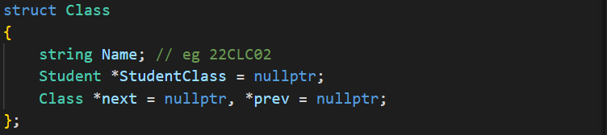

In creating a software application for the management of university students, the Class struct plays a crucial role.

* Name: a string representing the unique name for each class( e.g., "22CLC02").
* StudentClass: a pointer to a Student struct, which corresponds to the head of a linked list representing the collection of students enrolled in the Class. This enables efficient student enrollment, search, and removal operations within the class.
* next and prev: These attributes are pointers to the next and previous Class structs in a doubly linked list, enabling easy navigation between classes and efficient implementation of class-based operations like insertion, removal, and search.

As part of the bigger functional ecosystem of the software, the Class struct contributes significantly to streamlining academic workflows, improving resource utilization, and enhancing overall user experience for students, teachers, and administrators.

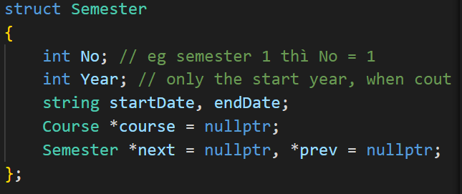

The Semester struct is a necessary data structure for managing academic semesters in the management system.

* No: a integer number represents the semester number.
* Year: a integer number represents the school year it belongs to (only the start year).
* startDate, endDate: strings represent the dates when the semester begins and finishes.
* course: a pointer to a linked list of courses in that semester.
* next: a pointer to the next semester in the same school year.
* prev: a pointer to the previous semester in the same school year.

The Semester struct is used to represent a single semester in a course management system. Overall, the Semester struct provides a convenient way to organize and manage information about individual semesters in a course management system. The use of a linked list for storing multiple semesters allows for easy traversal and manipulation of the data.

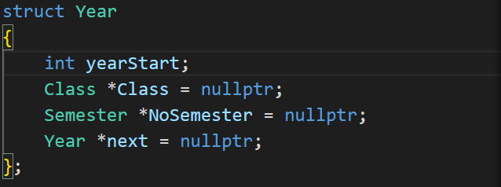

The struct Year represents a year in the course-management-system project. It has the following data members:

* yearStart: an integer that indicates the starting year of this year in the academic calendar.
* Class: a pointer to a Class object that represents the classes existed in this year. (such as 22CLC02, …).
* NoSemester: a pointer to the linked list of semesters in that year. There are 3 semesters in each year.
* next: a pointer to the next year object in the linked list of years. This is used to iterate over all the years in the academic calendar. It is initially set to nullptr.
* prev: a pointer to the previous year object in the linked list of years. This is used to navigate backward in the linked list. It is initially set to nullptr.

Overall, the Year struct is a convenient way to organize years in the academic calendar of the course-management-system project. It allows for efficient iteration and navigation through a linked list of years, and provides pointers to the courses taught in each year.

1. **Main components**
2. **[All] Section**

* File: [All]_Check_Validity.cpp: This file contains functions to check whether the value is valid or not
* The "CapitalClassName" function changes the class name string into the correct form (22clc02 -> 22CLC02).

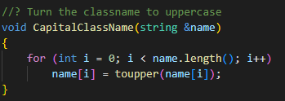

* "isValidStudentID" function checks if the student ID has 8 characters and the first 2 characters fit the year.

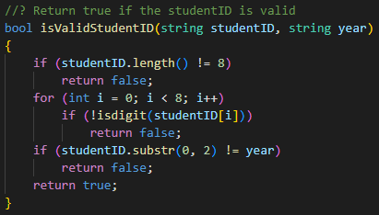

* "checkYear" check whether the newly created year existed or not.

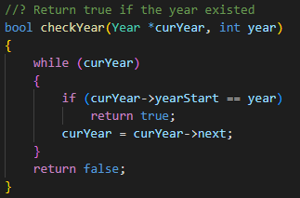

* "checkClass" check whether a newly created class existed or not.

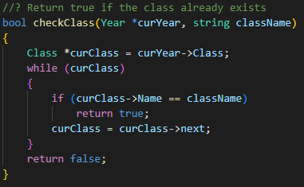

* "Check_Student" check whether a newly created student existed or not.

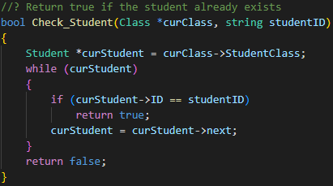

* "isLeap" is to check if the year is a leap.

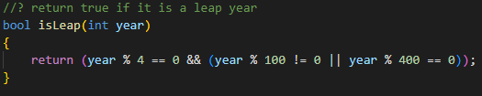

* "isValidDate" to check the validity of an inputting date.

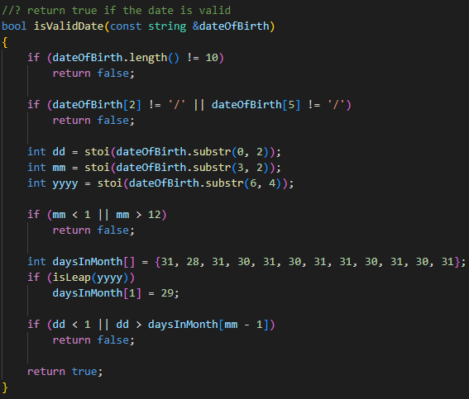

* "isDay" checks the string if it is in MON, TUE, WED, THU, FRI, SAT, SUN.

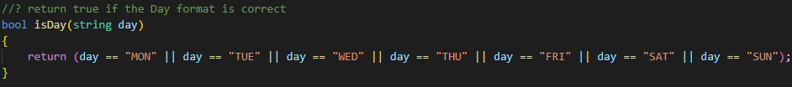

* "isSession" to check if it is in S1, S2, S3, S4.

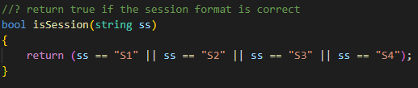

* "isValidGender" check input is M or F.

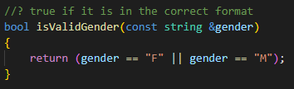

* "isValidYear" checks the format of the school year is yyyy_yyyy.

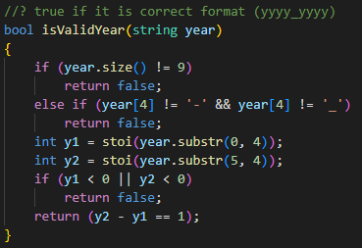

* "SeparateName" separates the full name into first and last name.

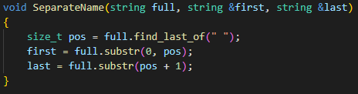

* File: [All]_Del_LL.cpp: This file consists of functions that delete all the created linked list
* "DeleteYear" function deletes every node of the linked list and the class with the student node inside it.

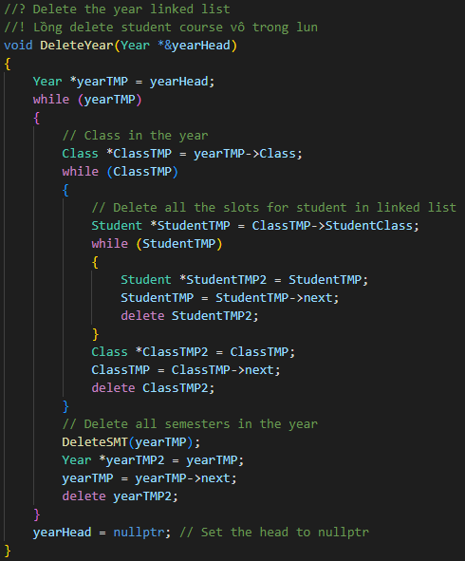

* "DeleteStudent" erase all instance of students in the linked list inside courses in the semester.

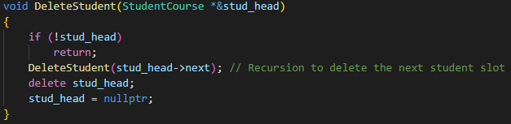

* "DeleteCourse" erase all instance of courses in the linked list inside the semester.

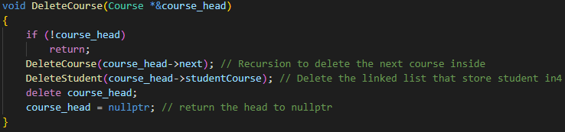

* "DeleteSMT" delete all semester in a current year and is put inside the "DeleteYear" function.

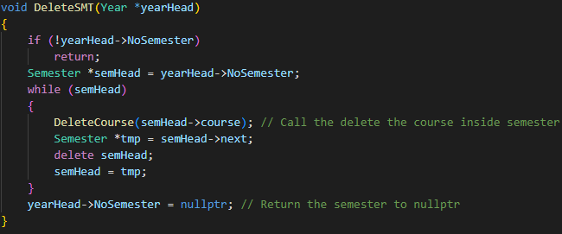

* "DelAccount" cleans up the space that the account linked list used.

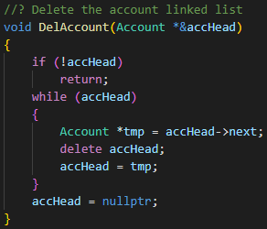

* File: [All]_Draw.cpp: contains all functions with the usage of drawing out the information that users can use the arrow button to move around.
* The "Draw_XY" takes in the list of options in order to print out the list of actions for the user to choose.

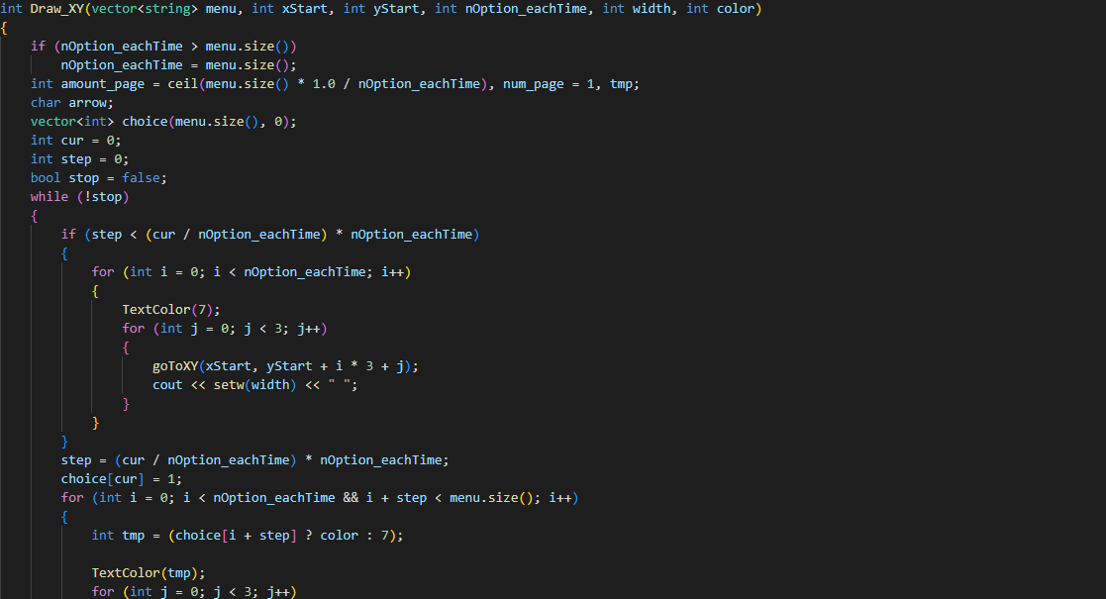

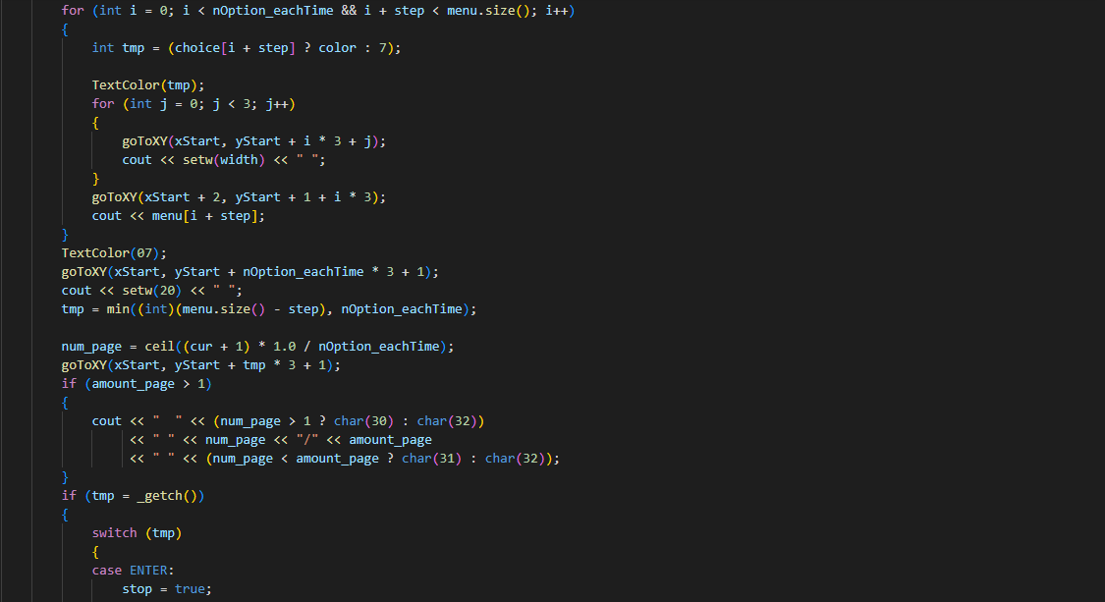

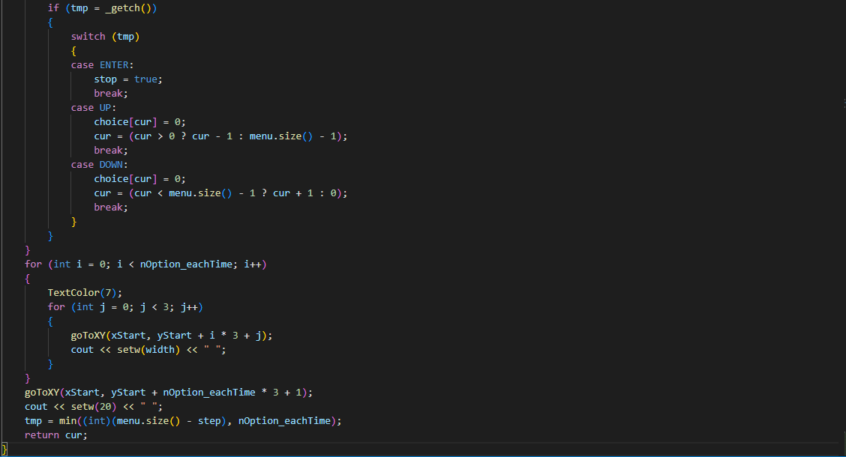

* The "Draw_table" takes in the 2d array to draw onto the console a table with its data passed in.

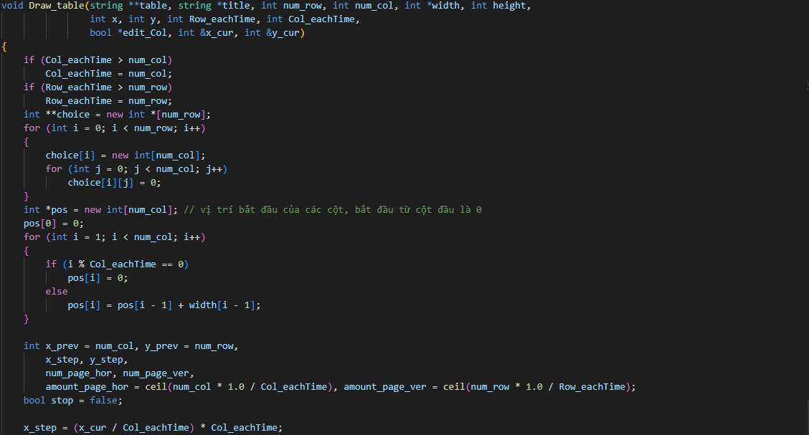

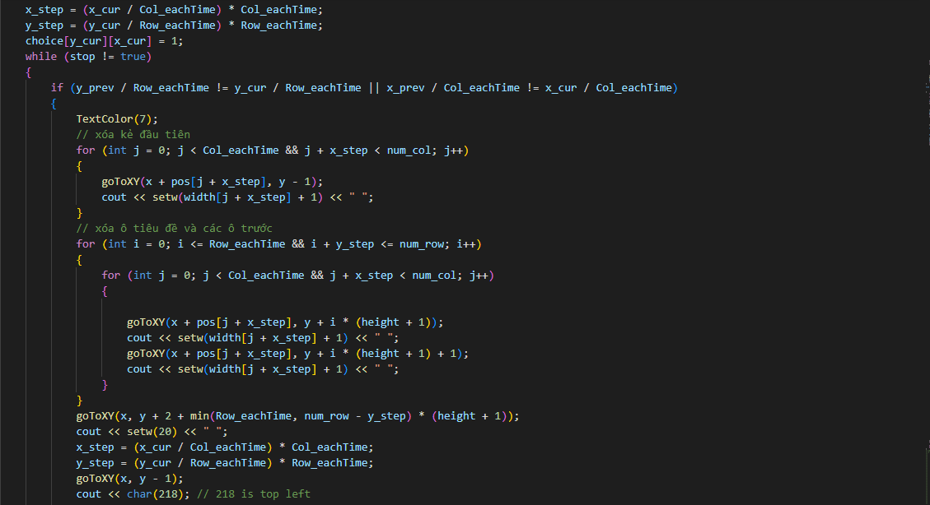

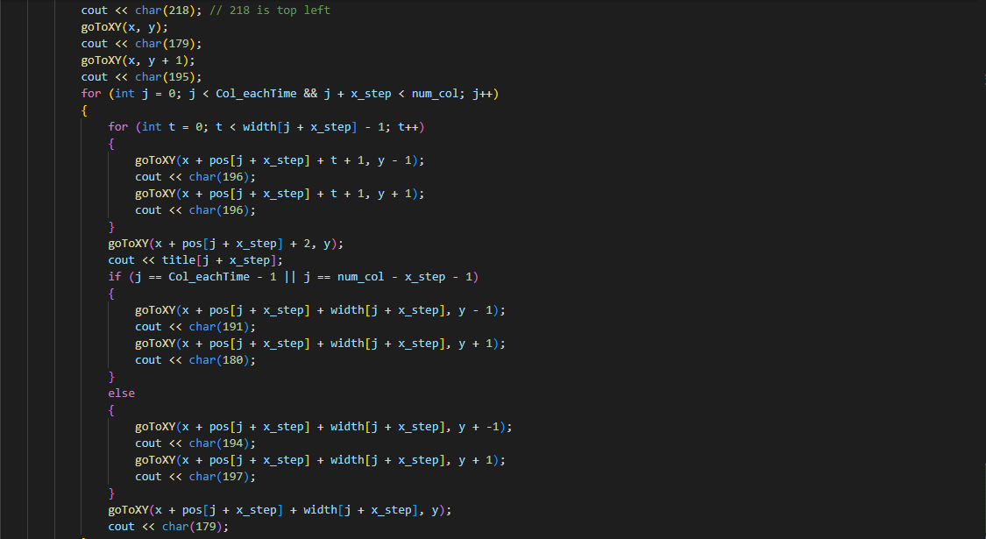

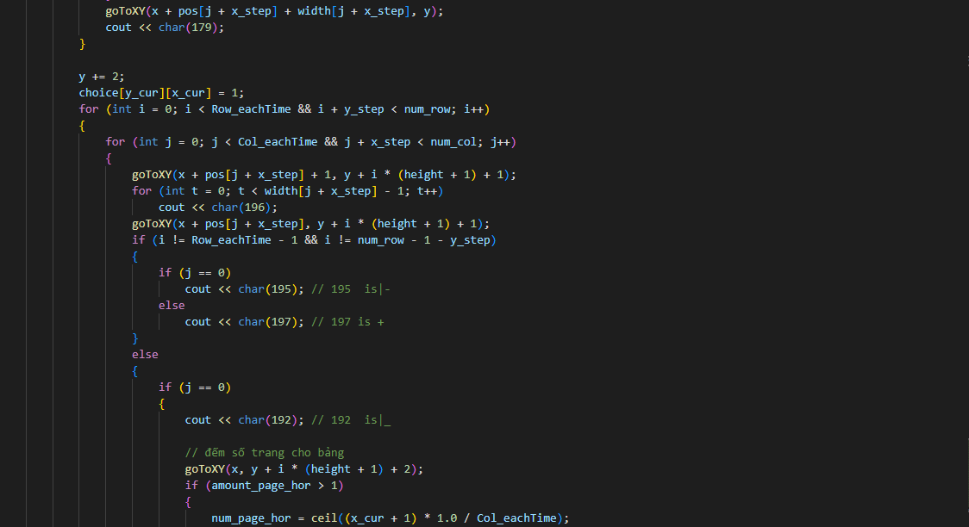

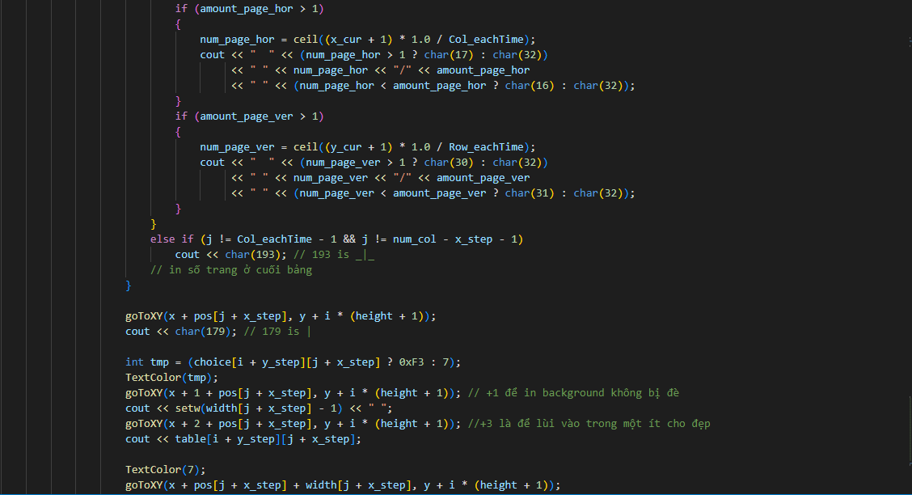

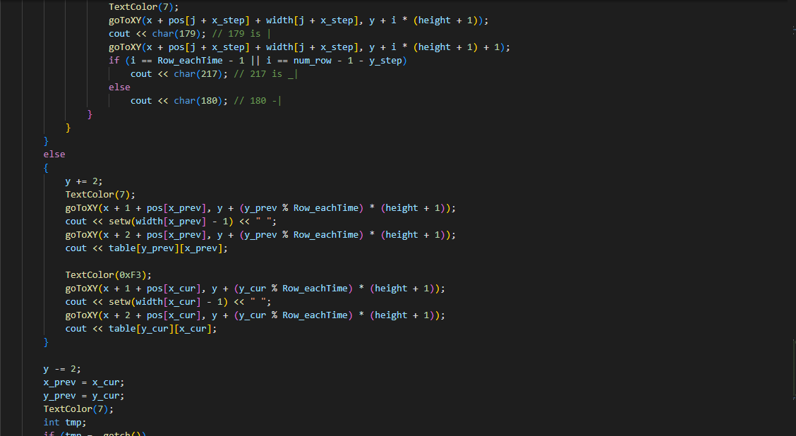

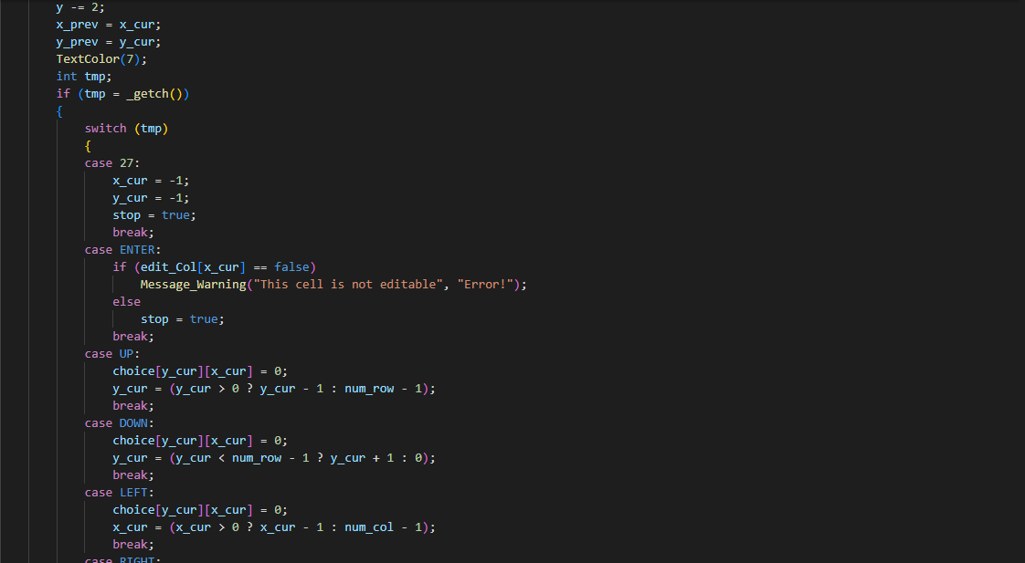

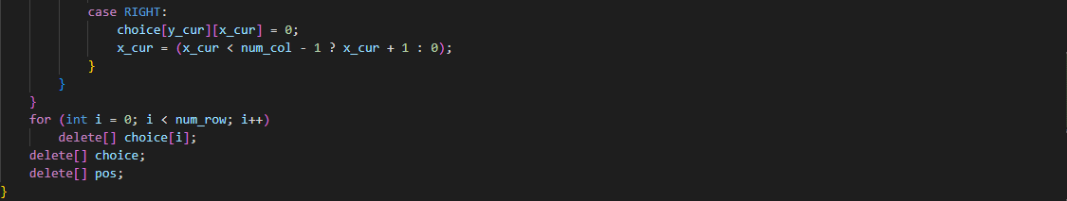

* "Draw_Horizontal_XY" is another version of Draw_XY but it is used to print out the table in the horizontal ways.

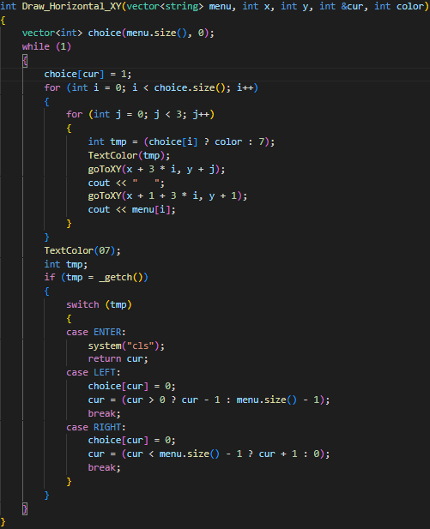

* "Draw_ShortVer" is another version of "Draw_XY" but the printout list only covers 1 block instead of 3.

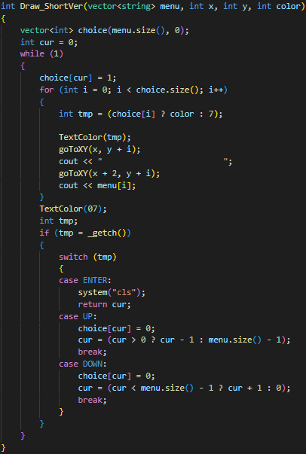

* File: [All]_Output_File.cpp: contains all methods of exporting files for saving purposes
* The "OutCourse" exports the course information in a semester to the file where store the semester information. The information output is the name, courseID, credits, max students, and a current number of students, ...

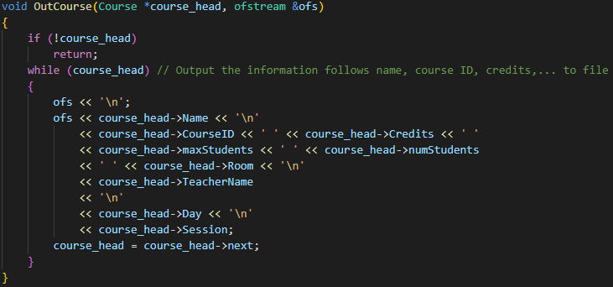

* "Output" exports the years, the semesters in the year, and the course information to the file 'in4smt.txt' in the corresponding folder.

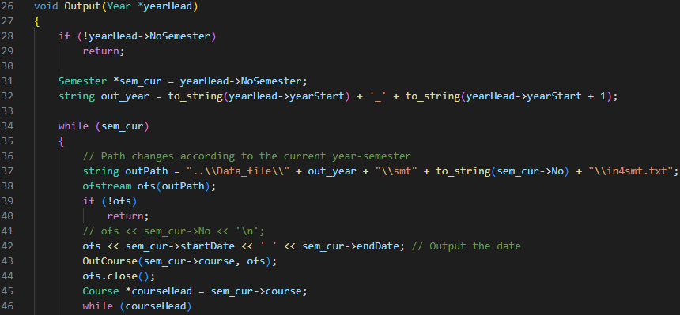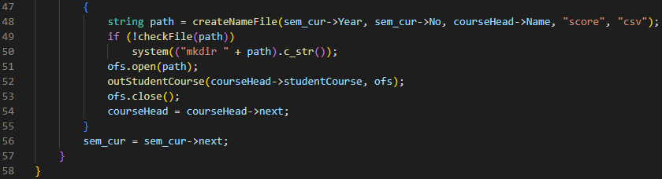

* "Write account" save the account and the user information to a file named 'account.csv'.

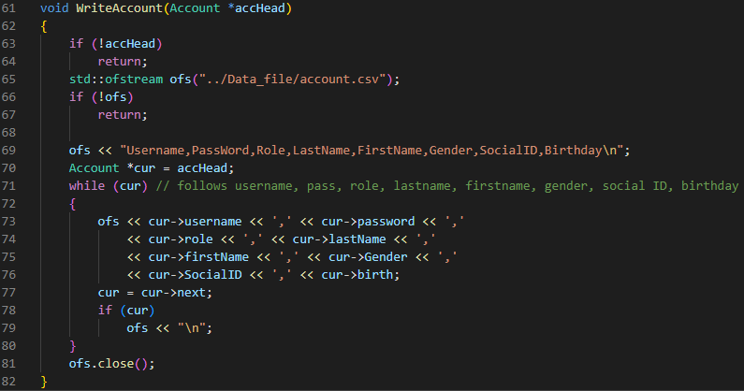

* "New account" is to create a new account for a new student and link it to the account linked list.

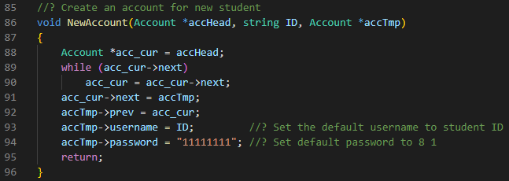

* "Outyear" saves the number of years in the 'years.txt' alongside classes and students in classes.

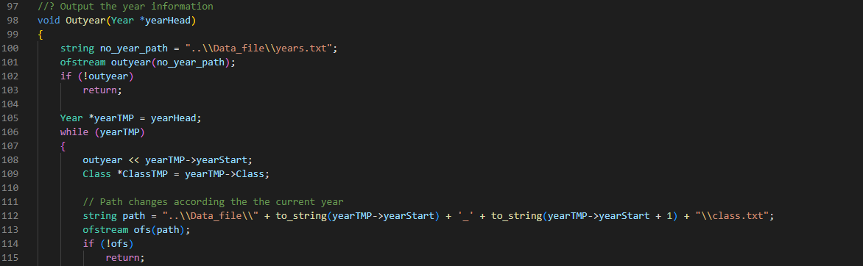

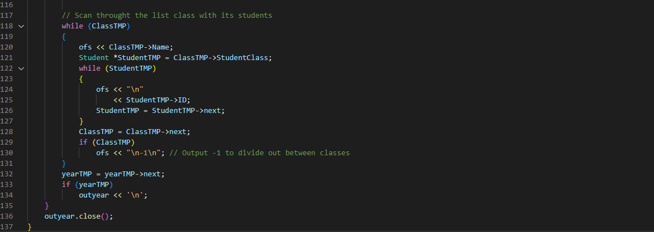

* "outScoreboard_StudentCourse" and "outStudentCourse" export the student's score to the corresponding csv files.

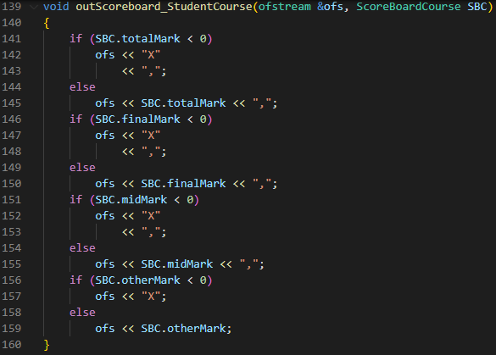

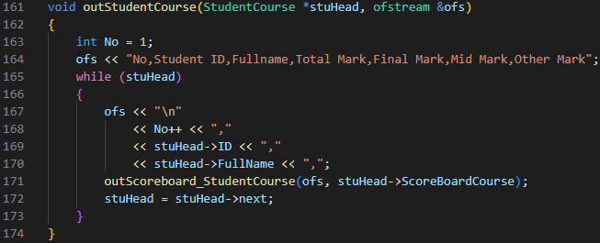

* "exportListStudentCourse" is used to create a folder and put allow those above functions to put files in it.

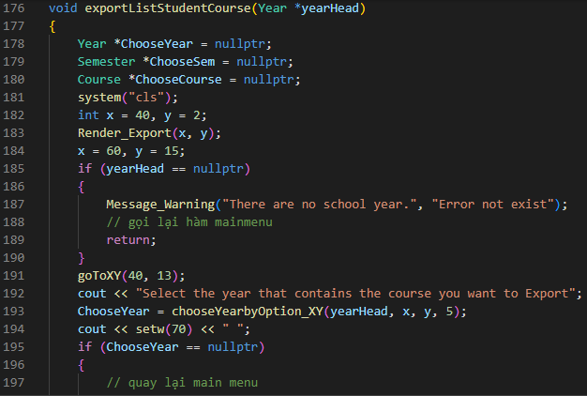

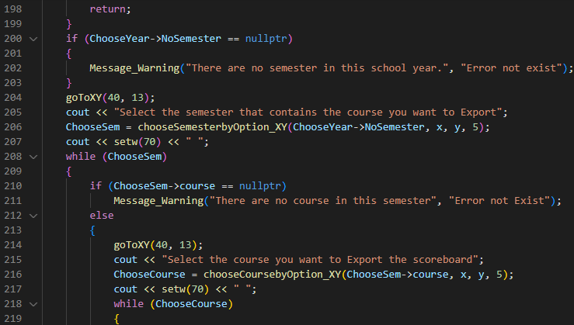

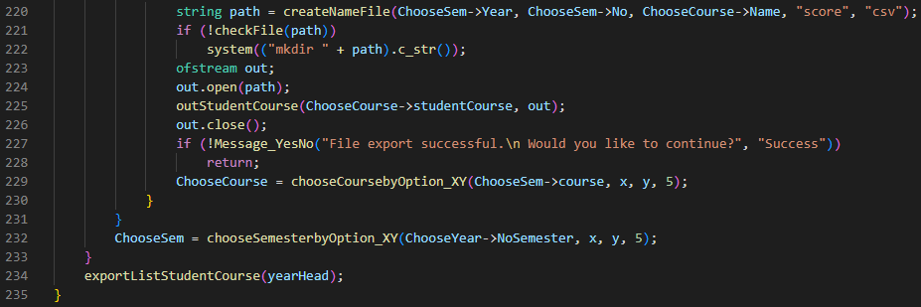

* File: [All]_Readin_File.cpp: contains all methods of loading information from saved files into linked lists
* "ReadAccount" loads back the user's accounts into the account linked list.

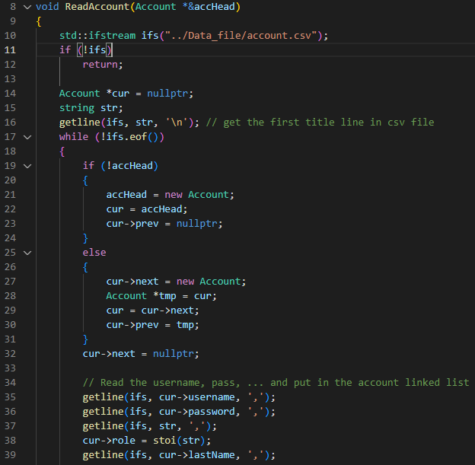

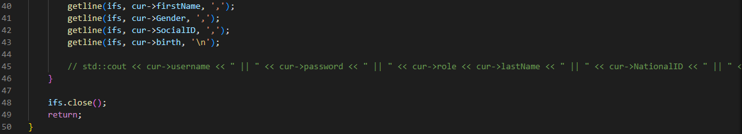

* "loadingFile" starts the loading process by calling the 'importYear' function.

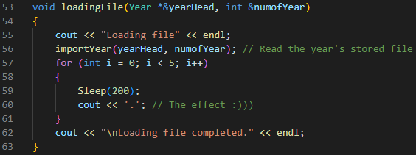

* "importYear" loads the year from the file into the year linked list.

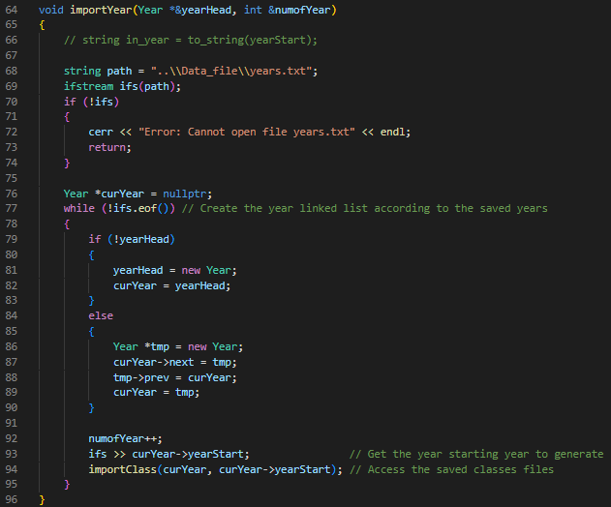

* "importClass" loads the classes and "addClass" creates the class linked list.

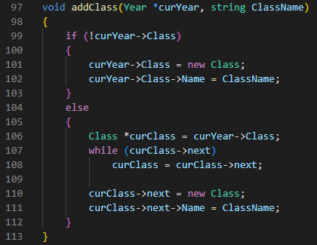

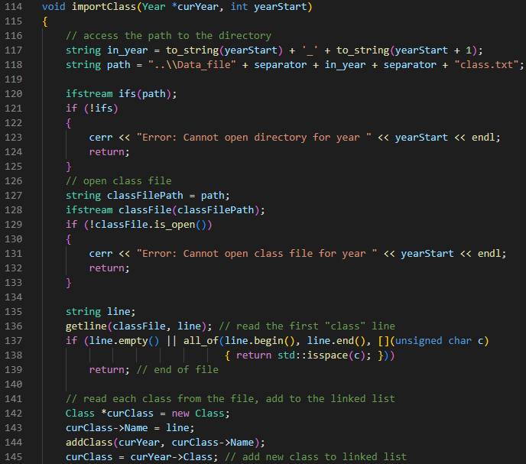

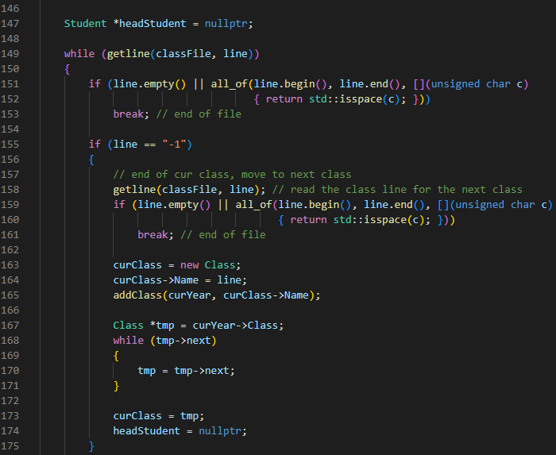

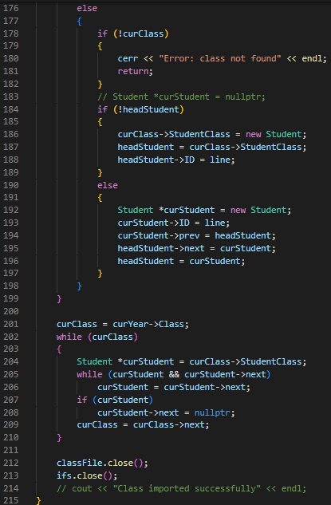

* "Read_Sem", "Read_All_Semester" takes the 'in4smt.txt' file to trace back all the saved information of courses and semesters.

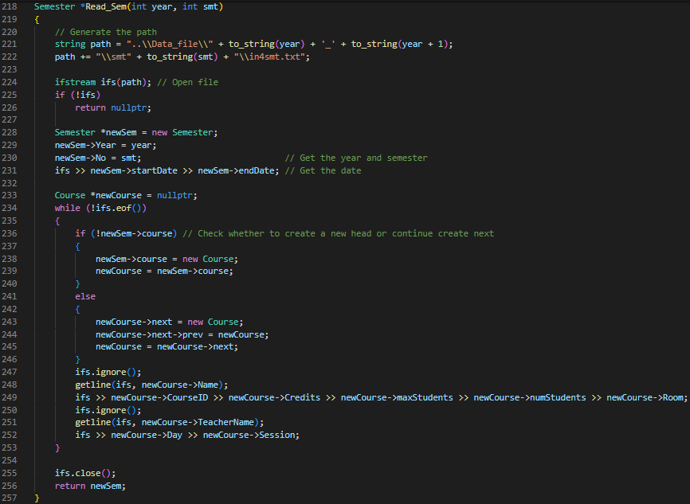

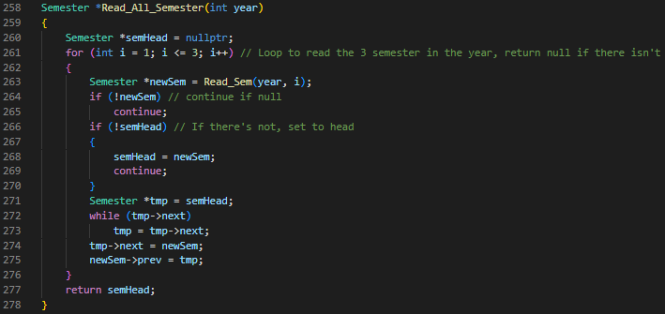

* "readScoreStudentCourse" and "readStudentCourse" takes the score of students and save them to the list.

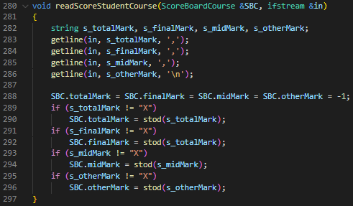

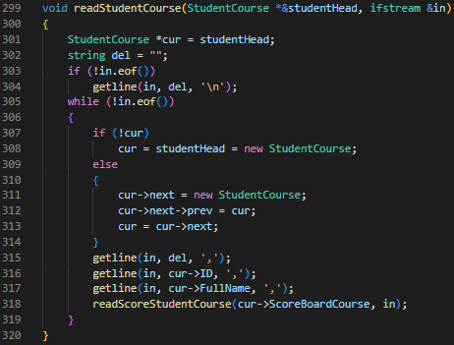

* "readAllFileCourses" and "importScoreBoardCourse" finds the files and call the above functions to read them.

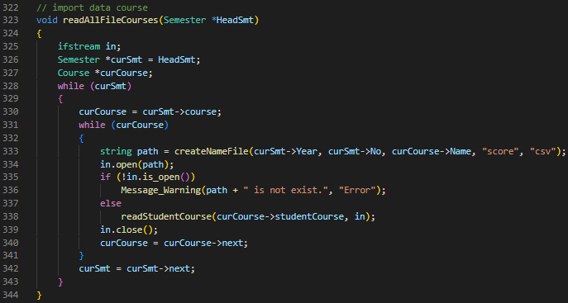

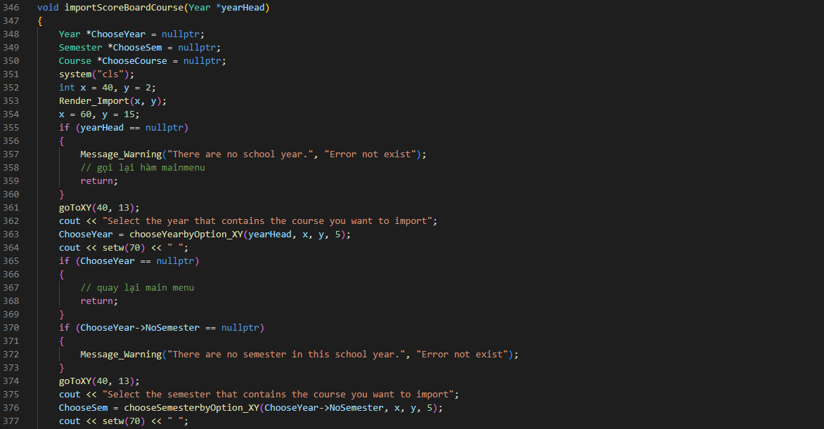

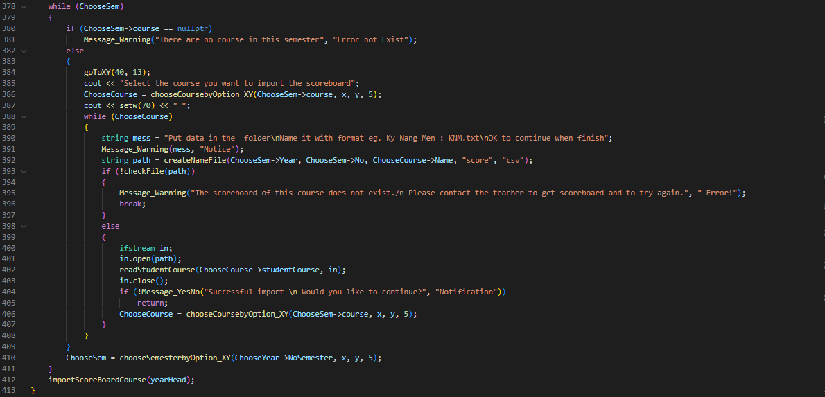

* File: [All]_Render_Text.cpp: storing all functions to print out the artistry of words, which functions take in value x and y to get the coordinate to print.

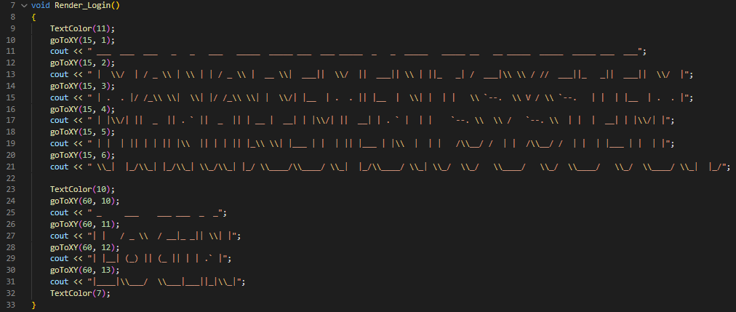

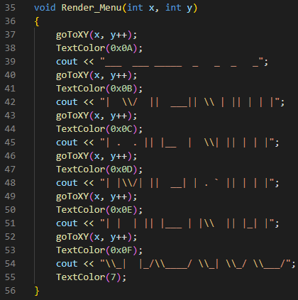

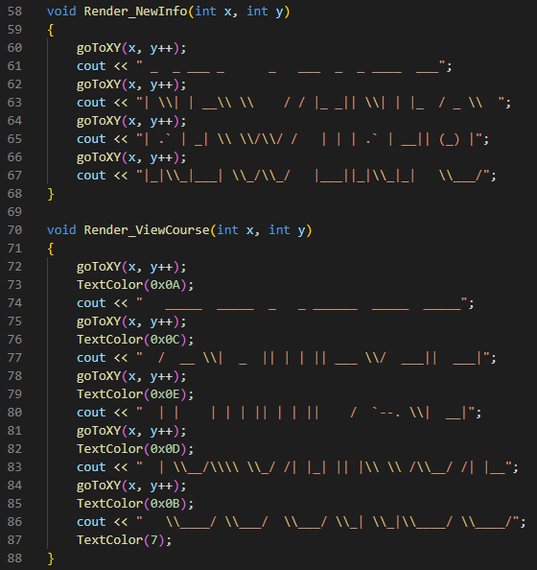

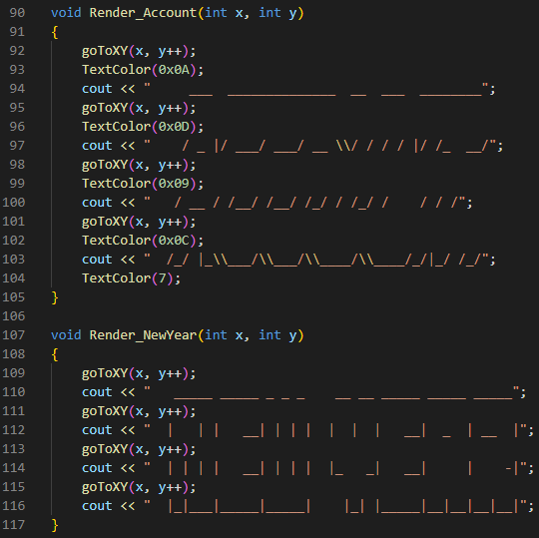

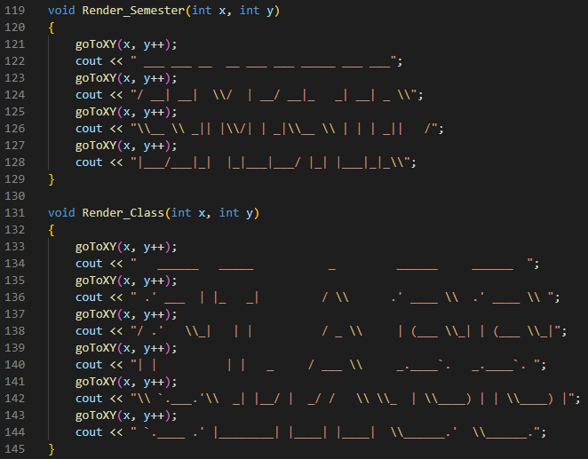

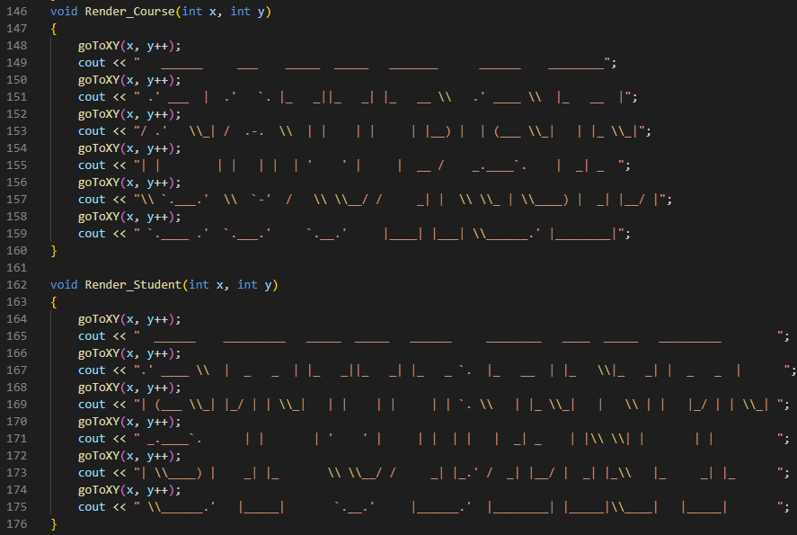

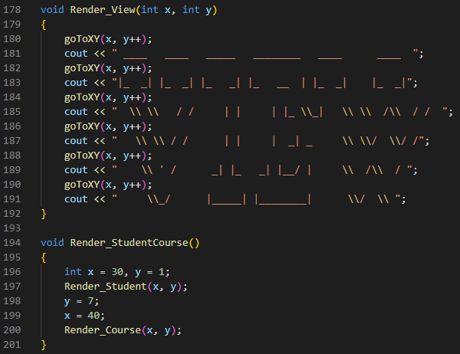

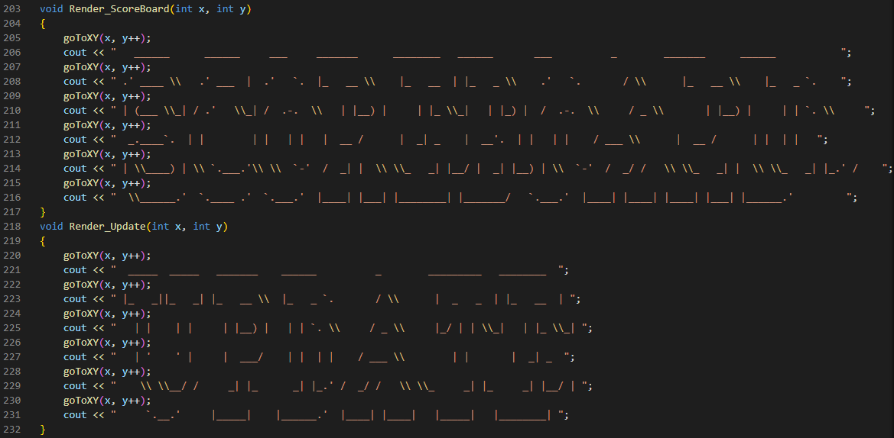

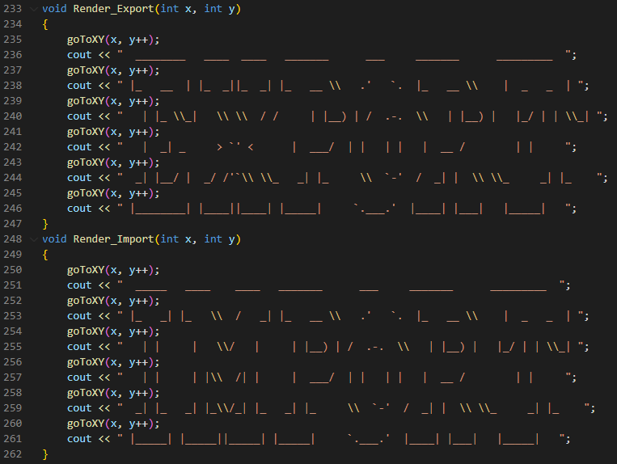

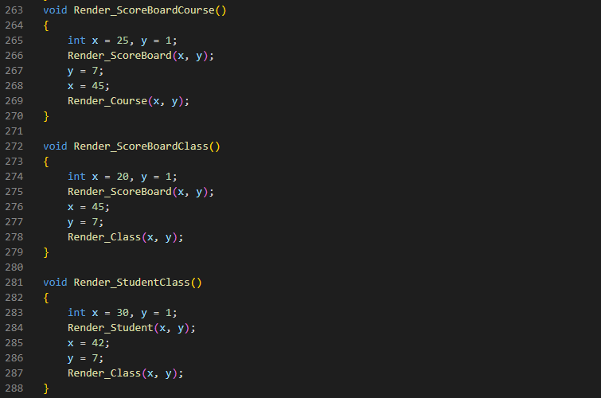

* File: [All]_Role_Menu.cpp: The menu of actions an account has.
* "Staff_Main" is the function, the menu of action for a staff showing when enter, which is account options, view, add, modify information, import or export data.

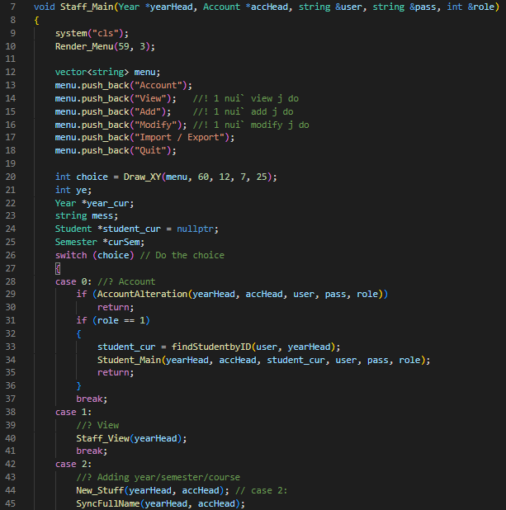

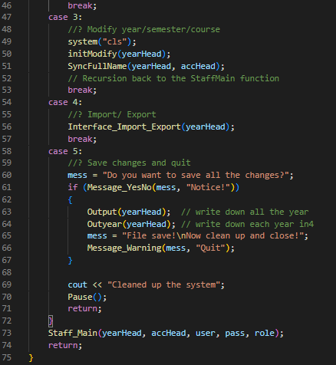

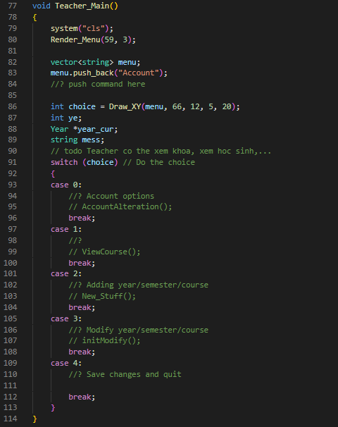

* "Student_Main" is the menu options for student accounts that students can manage the account, view the course, and score.

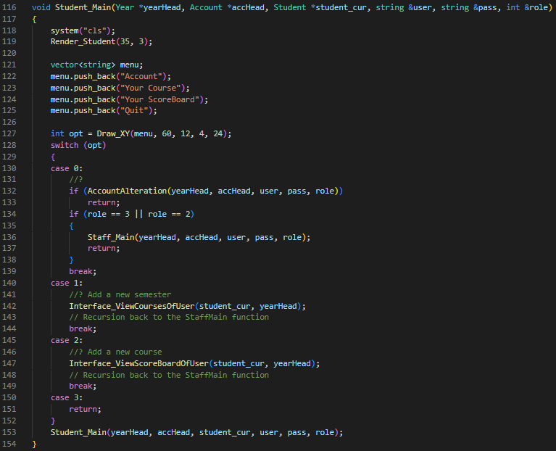

* "Main_Menu" is called when the user enters the system after login successfully. It will decide based on the account role and show the corresponding menu.

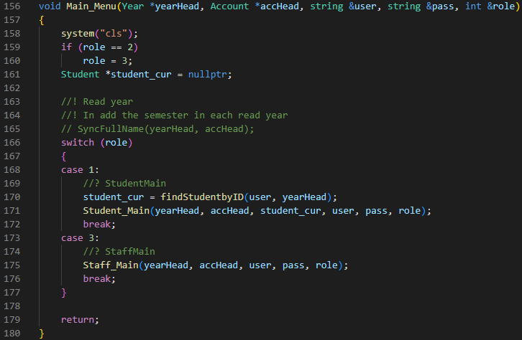

* File: [All]_Sort.cpp: has the function to swap the year
* "SwapYear" is used to swap the inside information that stores in a year linked list.

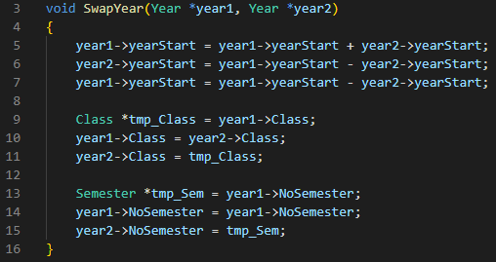

* "SortYear_Descending" swaps the year into the correct order.

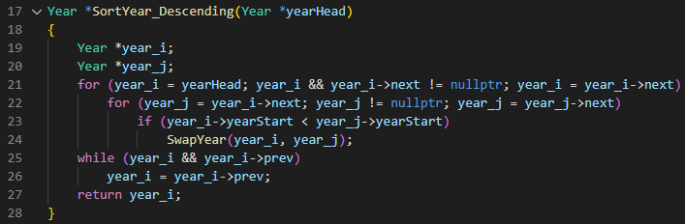

* File: [All]_Sync.cpp: has functions that allow the program to sync information across linked lists
* "SyncInForStudent" traverses the linked list of years and finds the correct account node to link to the student.

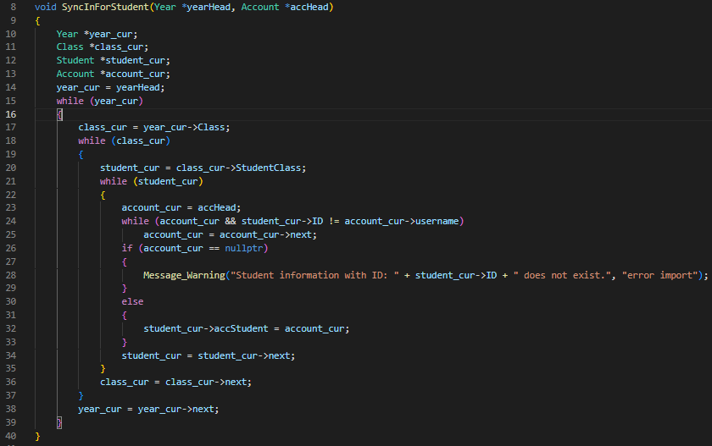

* "SyncCourse" gets all the course that student has put inside a linked list for better management.

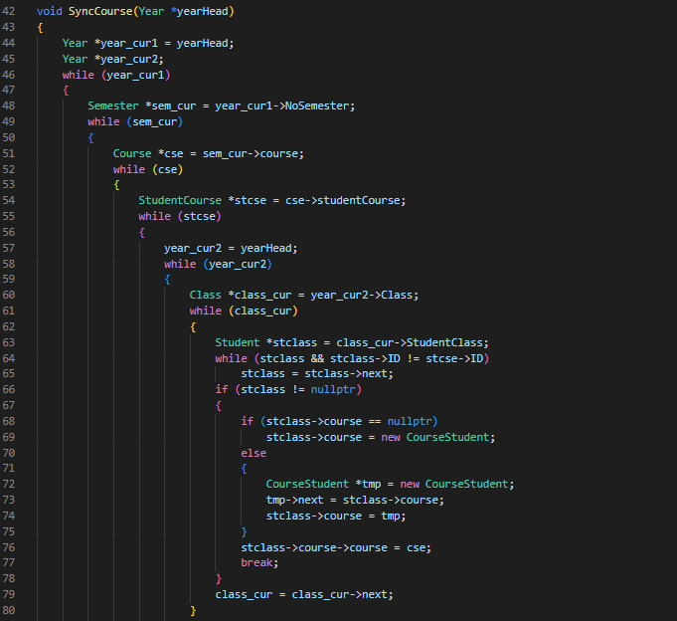

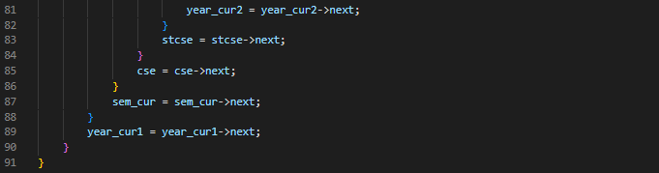

* "SyncFullName" traverse the year and account linked list to get the name of the student corresponding to the student ID.

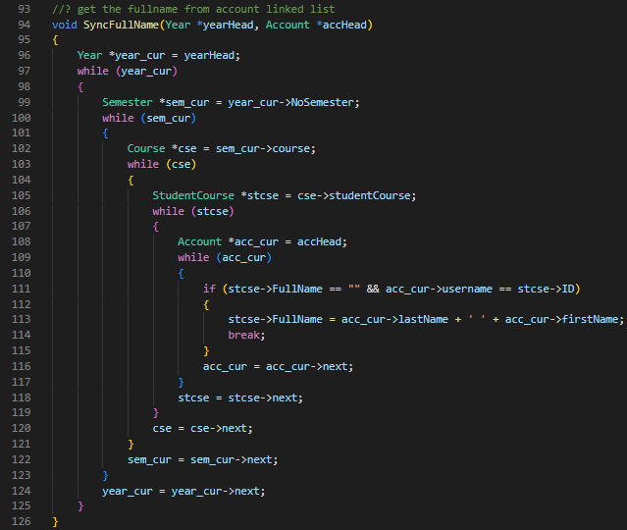

* File: [All]_Utilities.cpp: stores all the functions that use across files for managing the cursor and color purpose
* "ShowConsoleCursor" is the function that shows or hides the cursor.

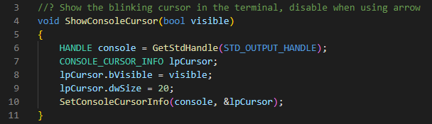

* "Pause": use the ‘conio.h’ style to replicate the 'pause' command line function.

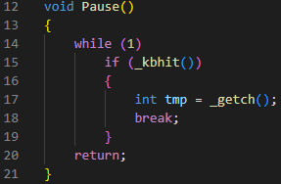

* "Message_Warning" and "Message_YesNo" are functions to show a message box with the inputting text and a button for users to click.

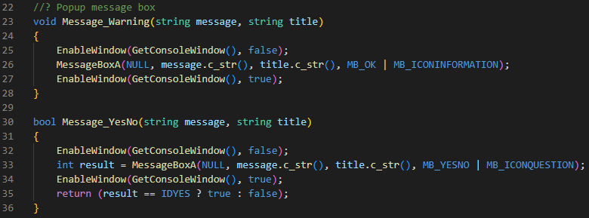

* "TextColor" changes the color of the console text.

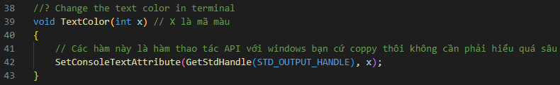

* "goToXY" moves the cursor to the inputting position.

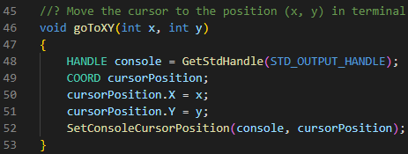

* "Limit_Input" replicate the std::cin by using ‘conio.h’ library and limiting the inputting length.

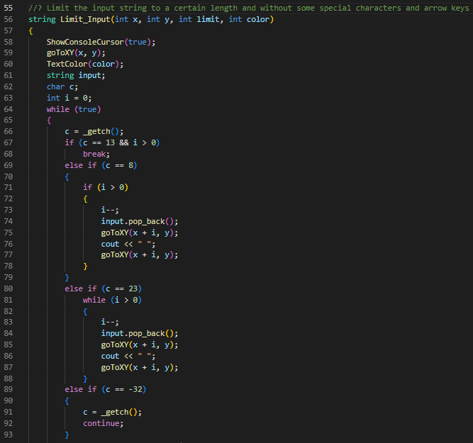

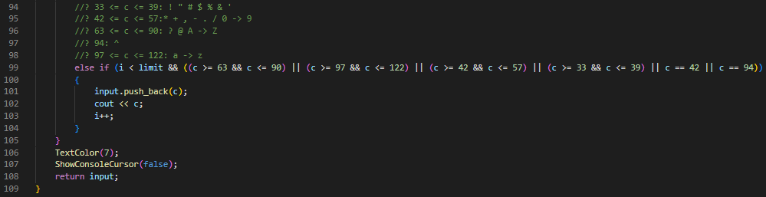

* "resizeWindow" resizes the console window to the fixed size.

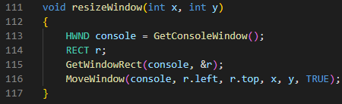

* "hideScrollBar" hides the console's scroll bar.

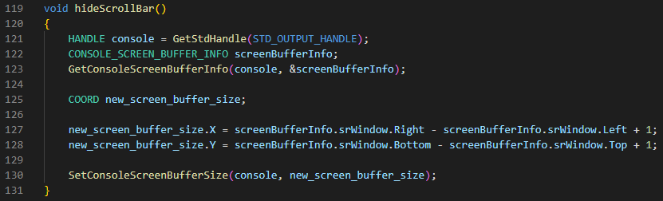

* "initWindow" initializes the console window by setting the size, and hiding the scroll bar,...

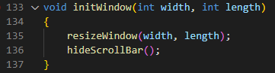

1. **[Sem] Section**

* File: [Sem]_Add_Course_Student.cpp: holds functions that allow users to create new semesters or courses with students.
  + "AddNewCourse" takes in the current chosen semester and the year linked list, then it prints to the console the necessary information for the user to input including the course ID, its name, teacher, its credits, the maximum number of students, the room and its time table. Finally, the function creates a new node at the end of the course inside the selected semester and returns back the node itself.

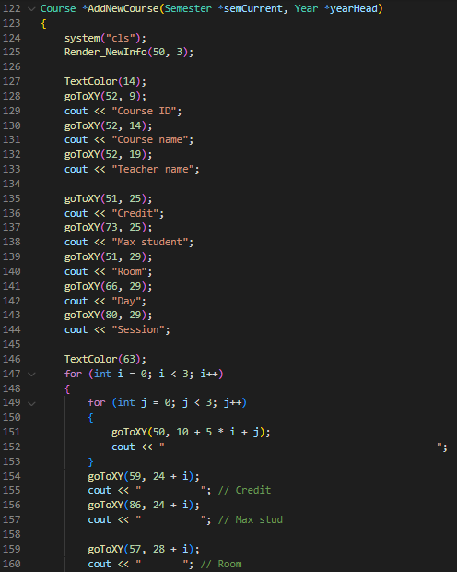

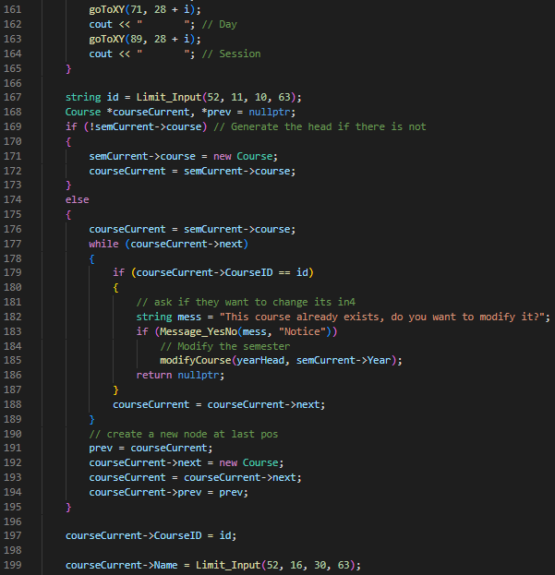

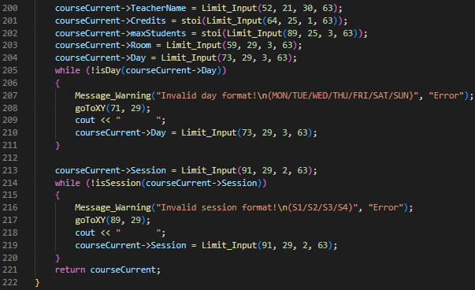

* + "ImportStudentFromFile" makes the user input the file name that the user put in the specific folder, then it reads the file and imports the student information into the student linked list.

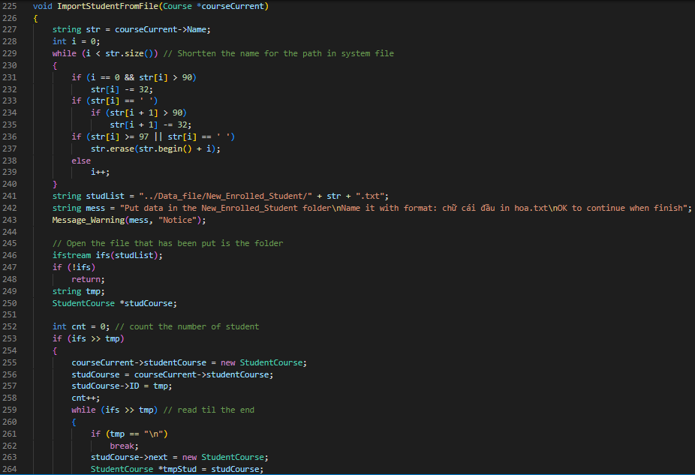

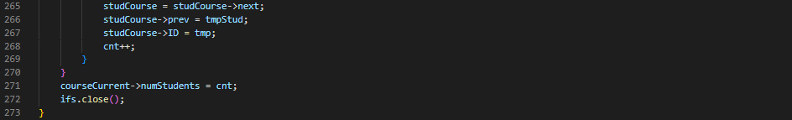

* + "AddStudentByHand" allows the user to input each student's information, then creates a new student node at the end of the linked list.

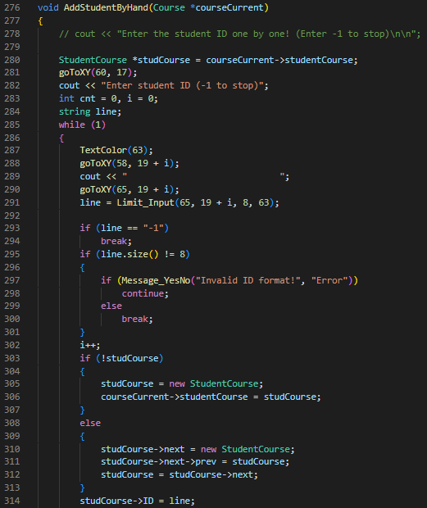

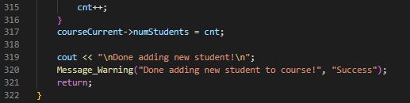

* + "AddingCourse" gives the user options to choose the way they want to add a student to the course, either by importing from a file or by hand.

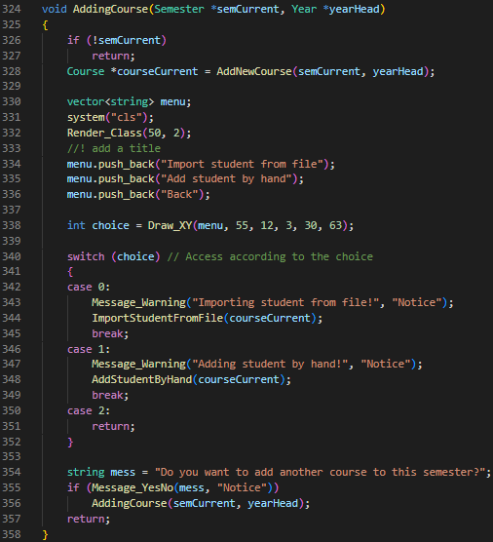

* File: [Sem]_Add_Semester.cpp: holds funtions that allow users to create new semesters or courses with students.
* “compareDate”: the function takes in 2 date strings and compare them, return -1, 0, 1 accordingly.

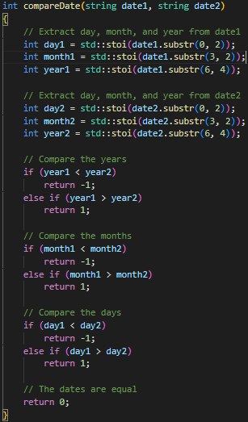

* "AddSemester" is a function that takes in the year linked list, creates a new semester node at the end of the selected year, then allows the user to input the starting and ending date of the semester. Finally, it returns the semester that just has been created.

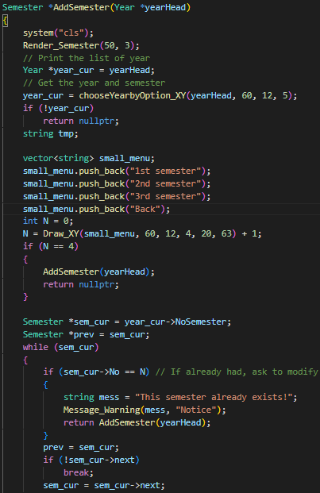

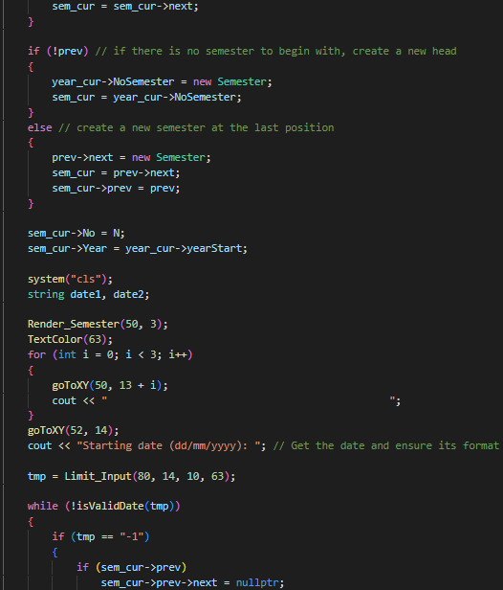

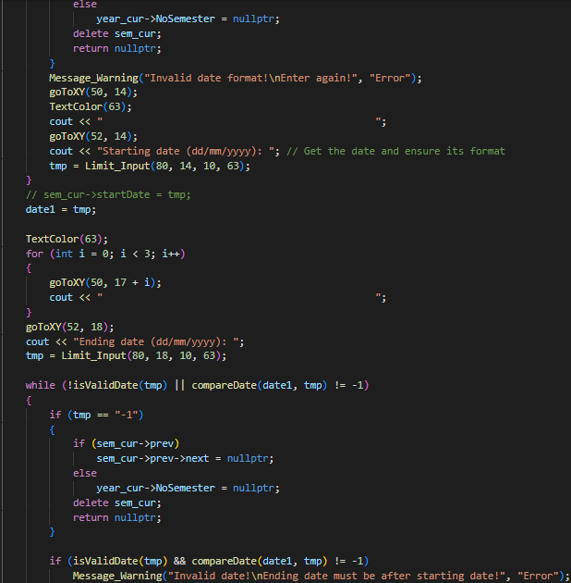 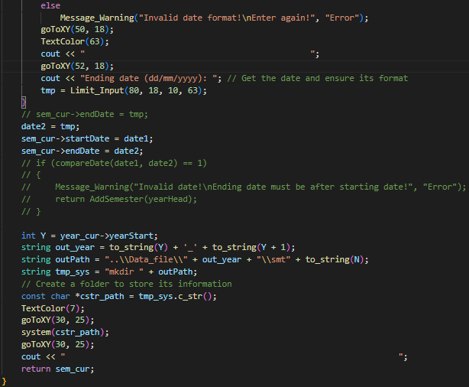

* “isStringDigits” takes an inputted string and check whether is contains only number of not.

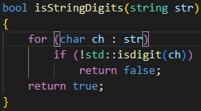

* File: [Sem]_Interface_New_Stuff.cpp has the 2 functions which call the corresponding functions.
  + "New_Stuff" shows the menu that the program allows users to choose to add to the program, which is to add a new year, a new semester, or a new course.

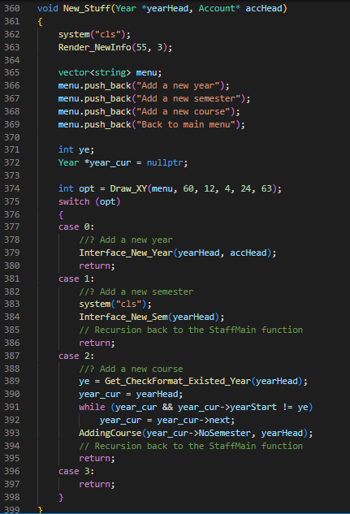

* + "Interface_New_Sem" gives the option for the user to use the follow-up function after making the addition of a new semester.

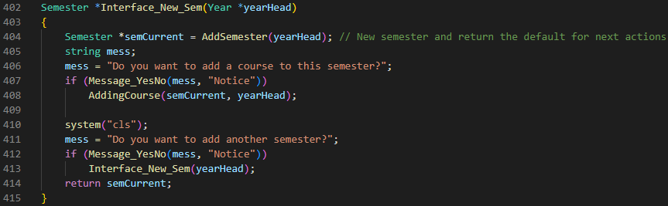

* File: [Sem]_Initialize_Modify.cpp has the 2 functions which call the corresponding functions.
  + "initModify" function shows the options for the user to modify the selected item, which is semesters, courses, students, and scoreboards.

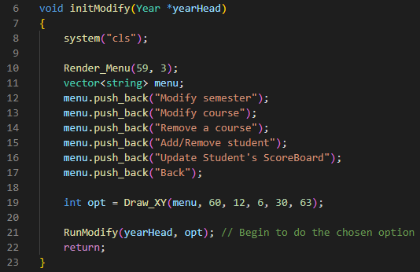

* + "RunModify" takes in the selected option and calls the corresponding function to modify the selected item.

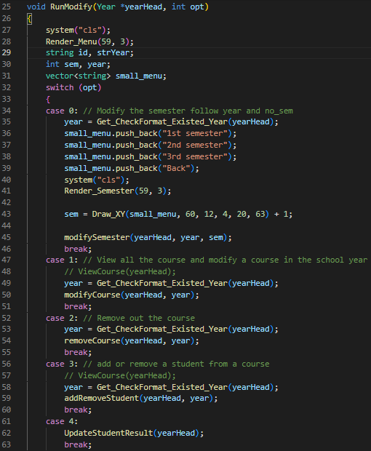

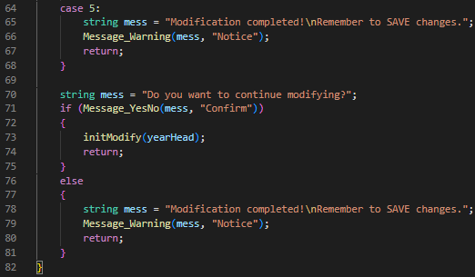

* File: [Sem]_Mod_Course.cpp: has the functions to enable modifying course information, or remove it.
  + "modifyCourse": first it finds the chosen year node, then allows the user to input the course ID, then perform the modification in "ChangeCourseInfo" function and notices to the user whether the modification is successful or the course is not found.

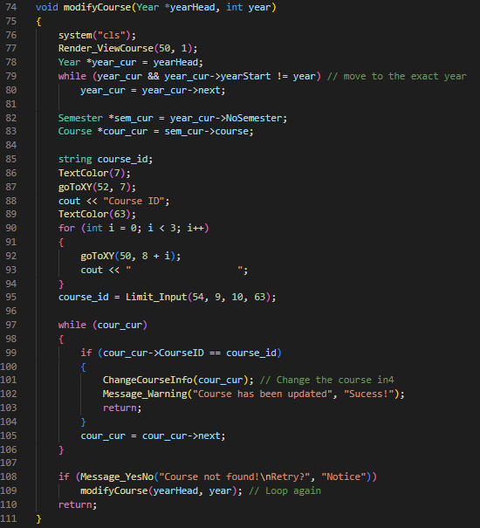

* + "ChangeCourseInfo" shows the current course's information and has the user to choose which information they want to modify and then update to the course node.

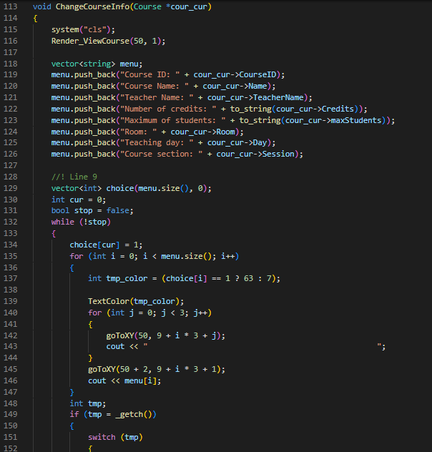

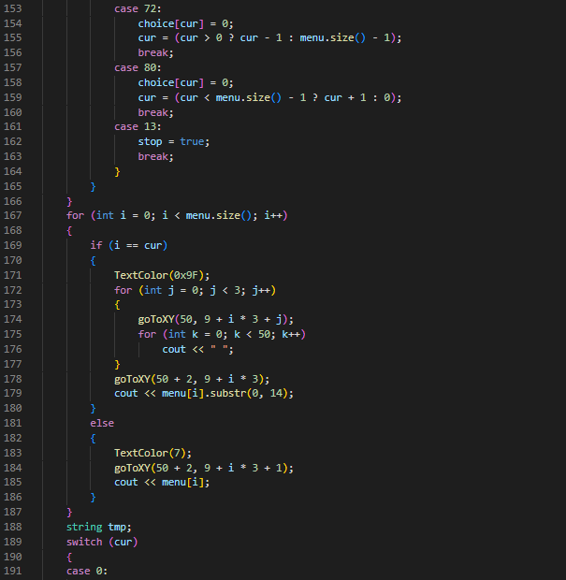

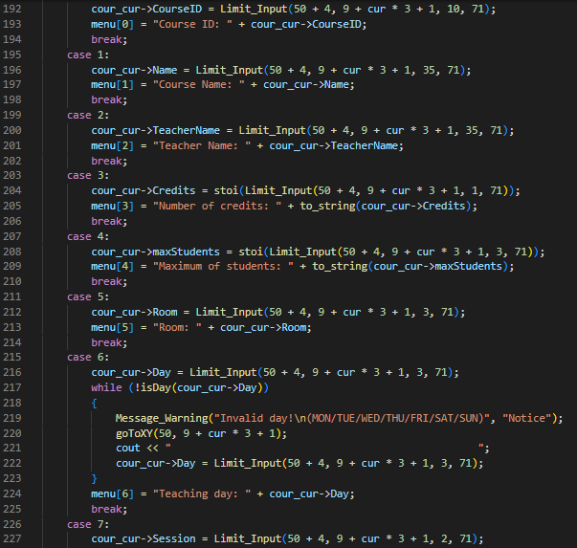

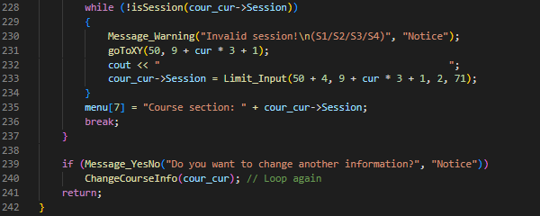

* + "removeCourse" first find the chosen year node, then gets the inputting course ID and checks whether it exists or not, if it exists, remove the course node and notify the user whether the course is removed successfully or not found.

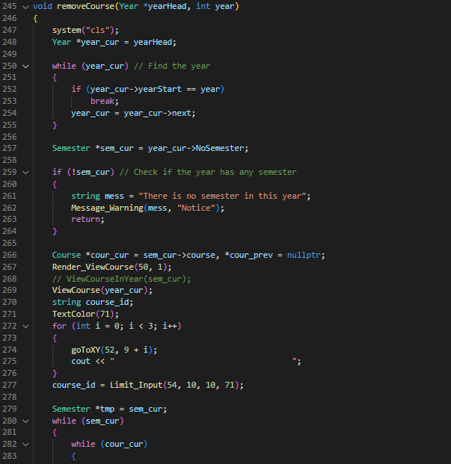

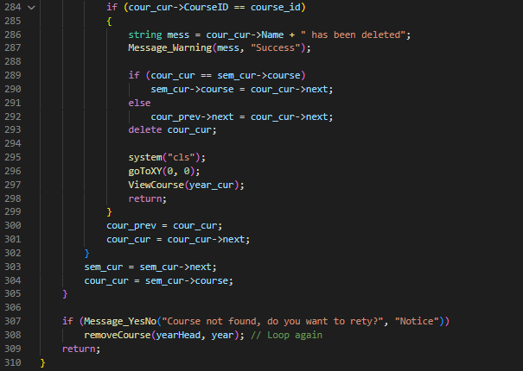

* File: [Sem]_Mod_Sem_Student.cpp contains functions that make modifications to semester and enrolled students in a course.
  + "modifySemester" takes in the full year linked list and traverses through it to get the needed year and performs modification of the semester's start and end date.

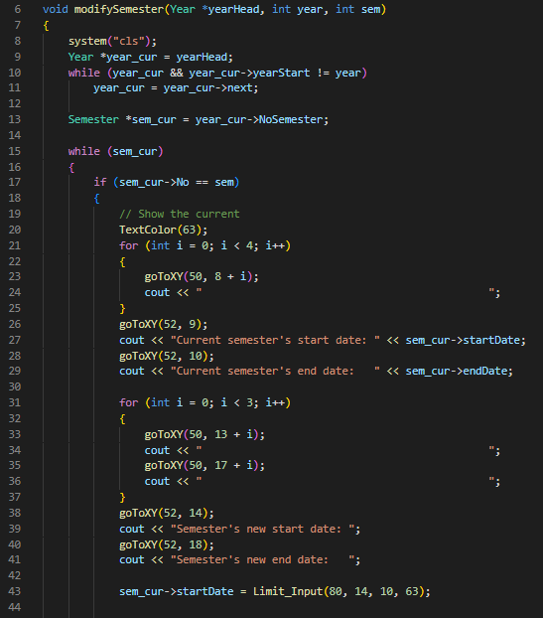

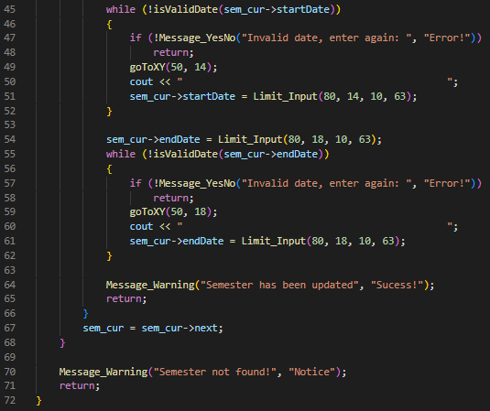

* + "addStudent" takes in the current course and the course ID to begin adding new students to the course by entering their student ID.

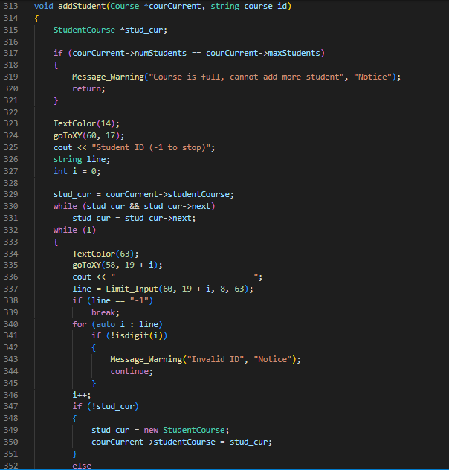

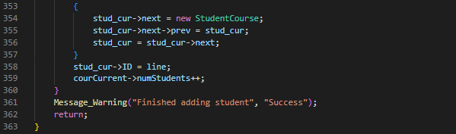

* + "removeStudent" other hand gets the course linked list and the course ID itself to remove a specific student from that chosen course.

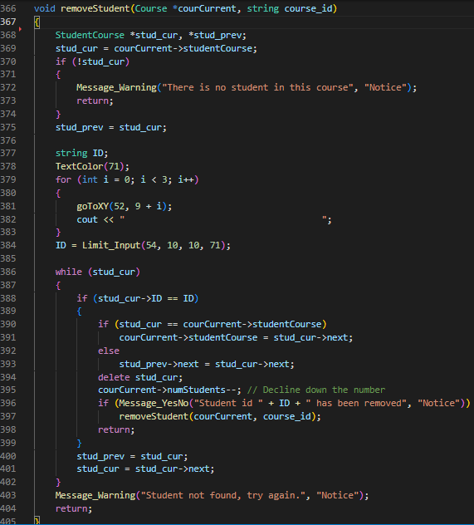

* + "addRemoveStudent" is the function that allows users to choose whether they want to add or remove students from the course.

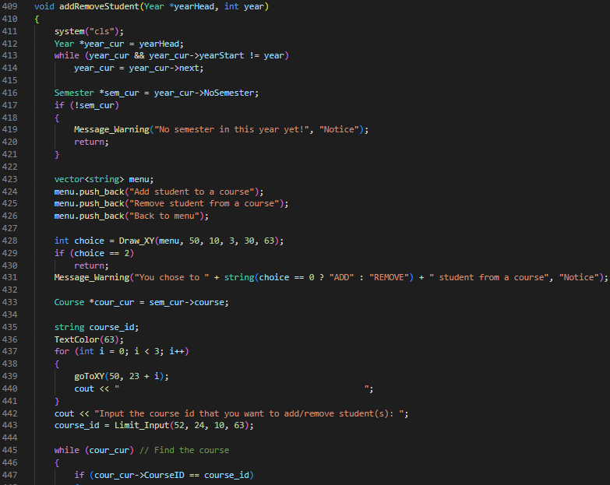

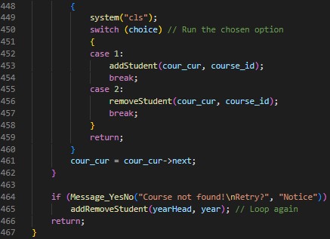

* File: [Sem]_View_Course.cpp: holds the option to print out courses in a year.
  + "Tablize" function takes in 0 for the head, 1 for the body, and 2 for the tail to draw the horizontal line of the table using ASCII characters.

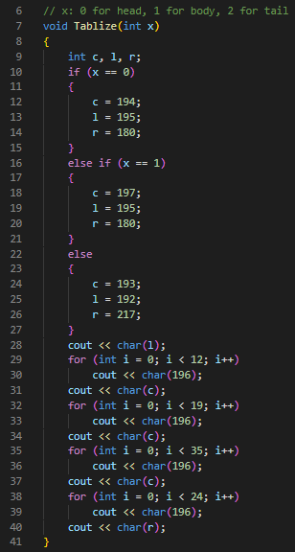

* + "Part_Of_Course" prints out the list of courses inside a table with the year. Users can use the arrow keys to navigate through the table in semesters and years.

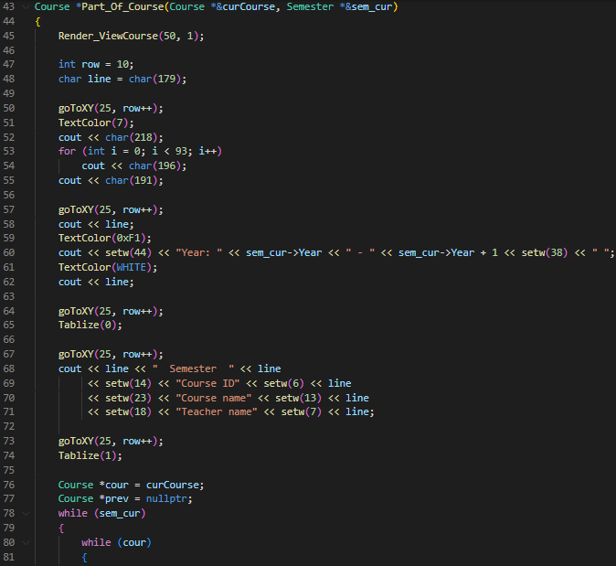

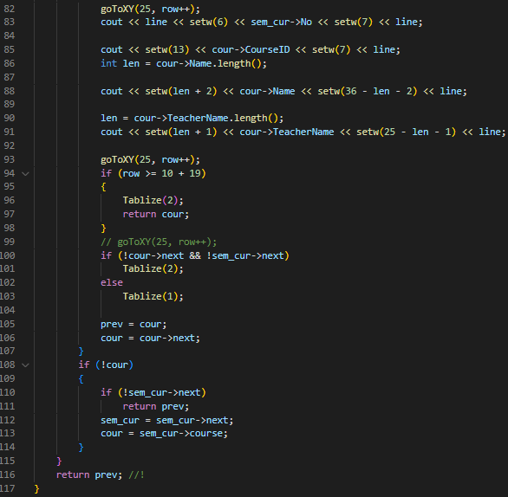

* + "ViewCourse" finds the number of pages that the list of courses fits in and handles the work of getting arrow keys to navigate the course for the 'Part_Of_Course' to print the course out.

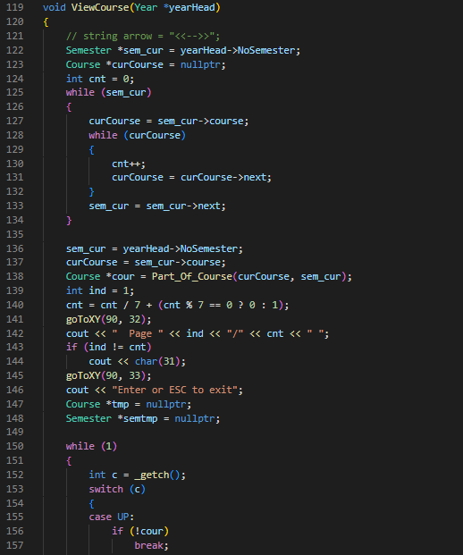

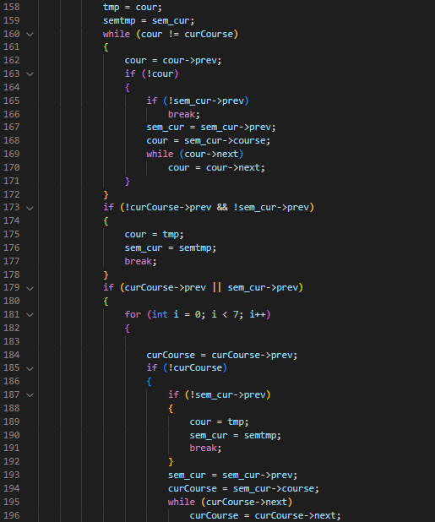

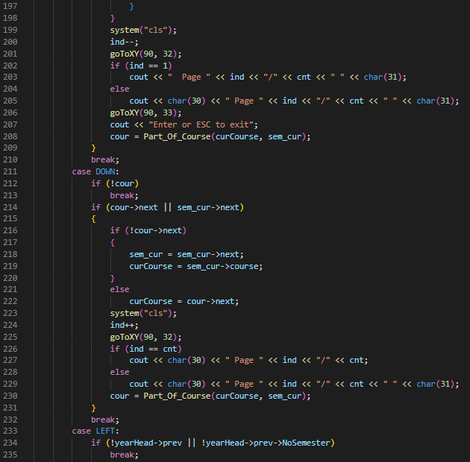

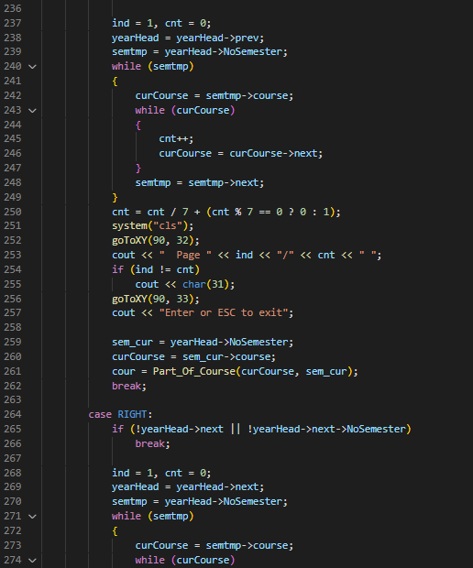

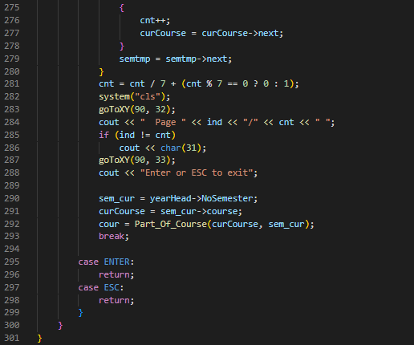

1. **[Sem] Year**

* File: [Year]_Add_New_Year_Classes.cpp: holds functions that create new year node and classes addition operations
  + "createSchoolYear" first checks the year, then if not create a new year node at the end and create a new year path in the saving folder.

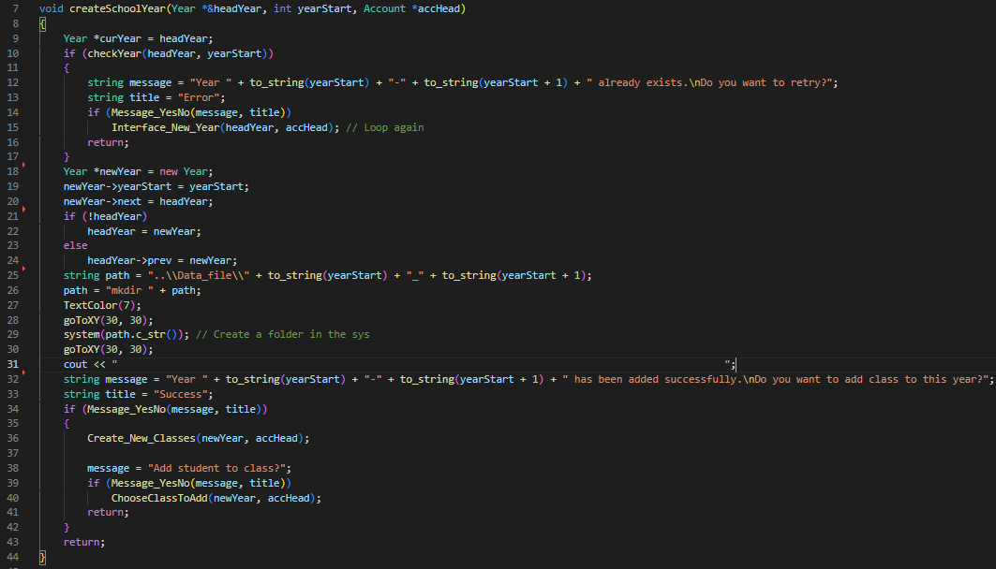

* + "Create_New_Classes" allows users to create new classes according to the newly created year and put them in the class linked list.

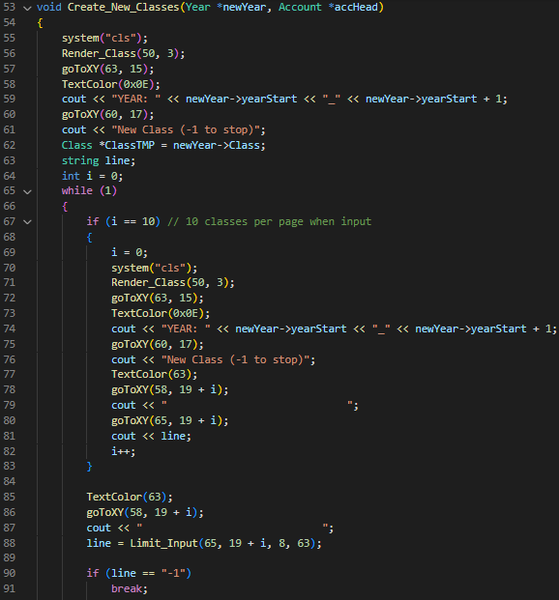

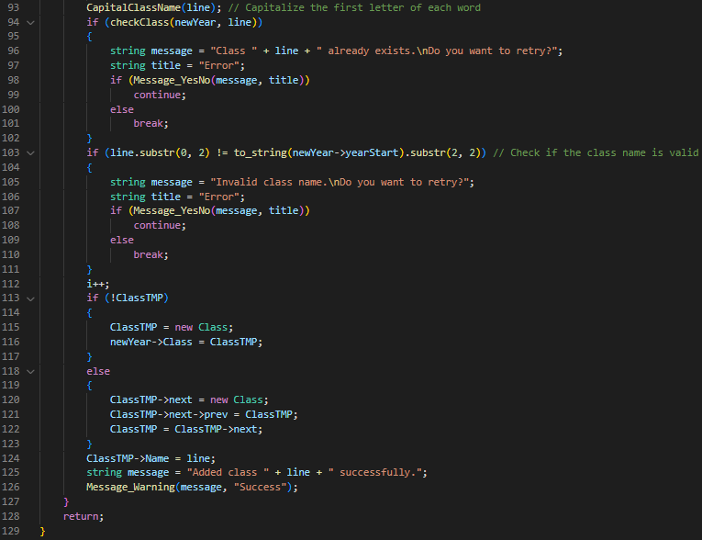

* + "ChooseClassToAdd" prints out the classes for users to choose to begin adding students.

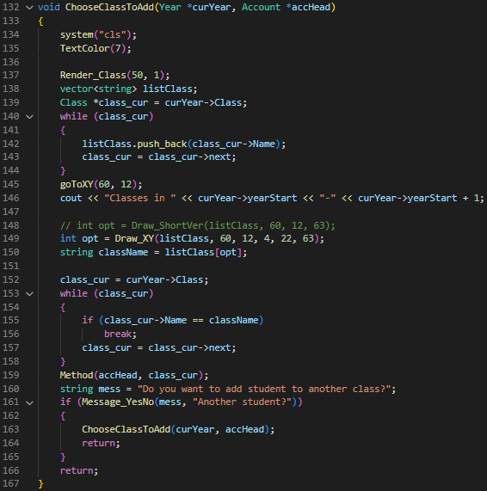

* + "Method" contains the style the users want to add students either by hand or from the file.

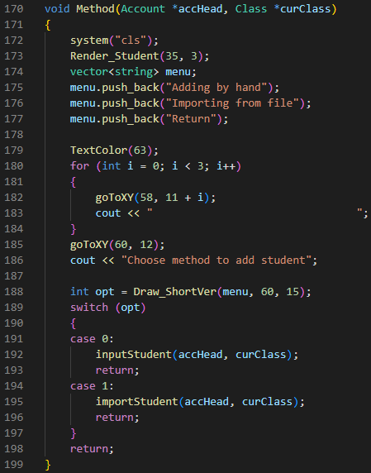

* + "inputStudent" begins to print out the list of information that needs to be filled in.

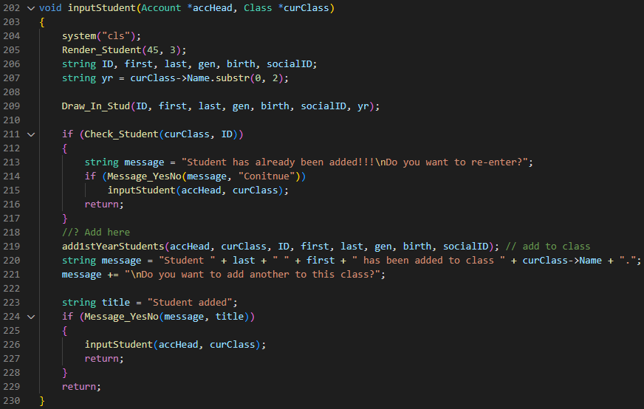

* + "importStudent" has the users choose the file they want to import new students to classes and perform operations for the data to fit in the linked list.

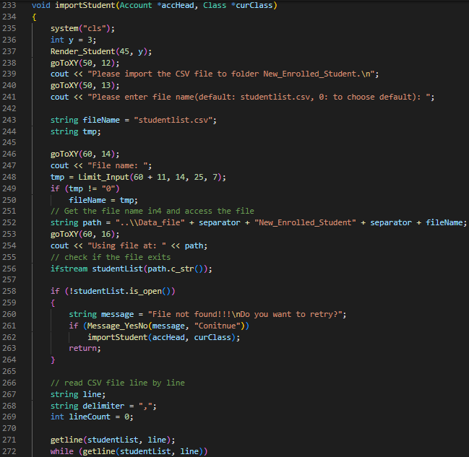

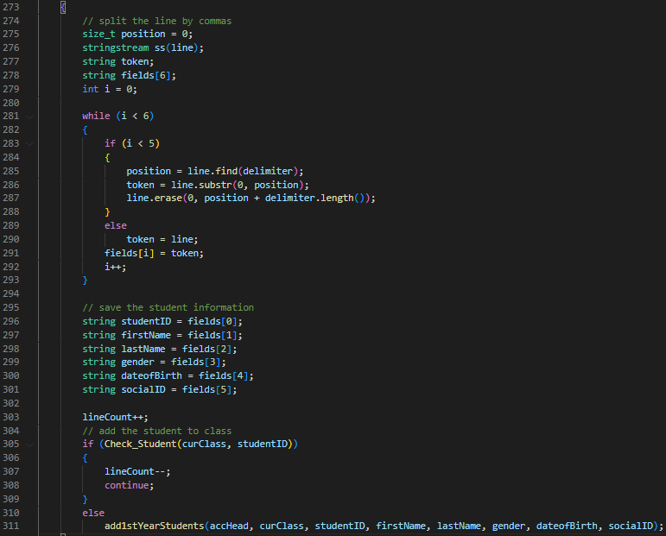



* + "add1stYearStudents" uses the new student information and adds them to the new node of students in class linked list.

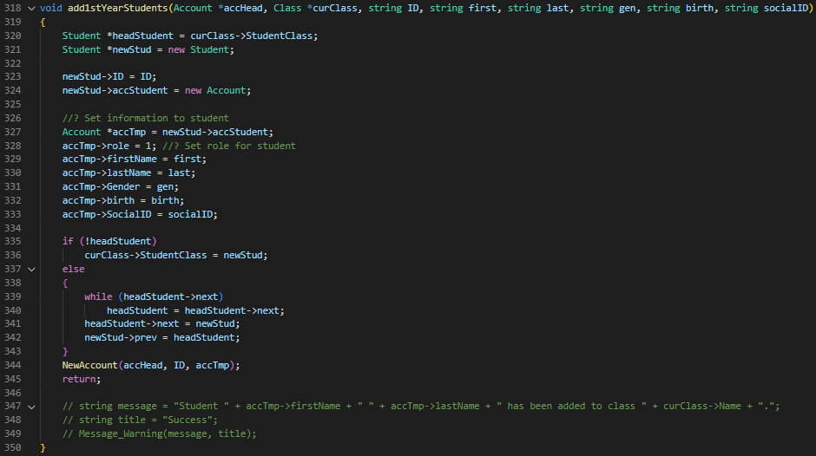

* + "Draw_In_Stud" prints out the boxes the user enters the student's information and checks for their validity.

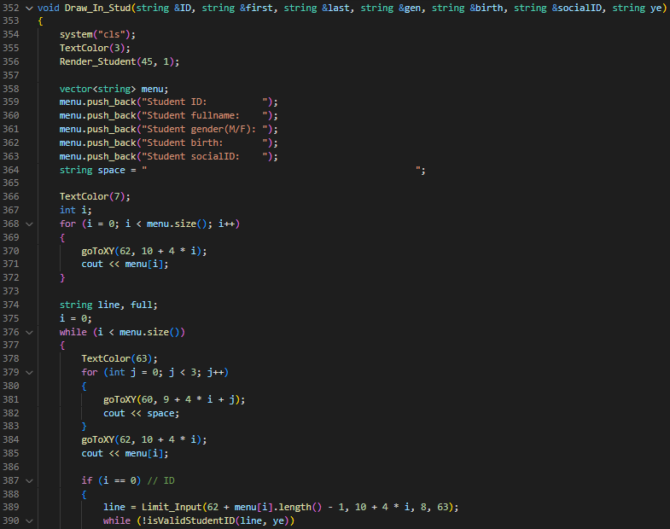

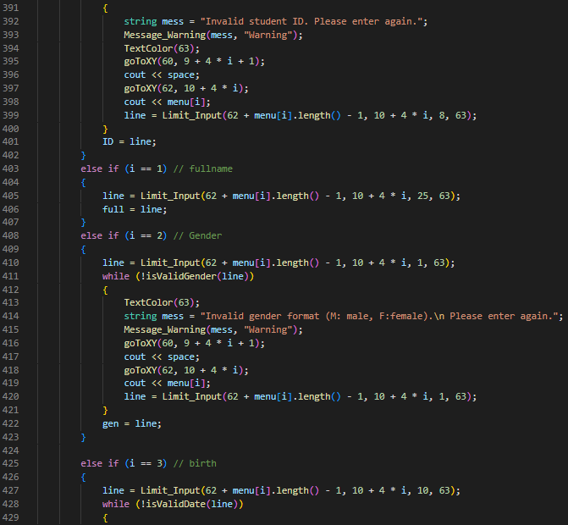

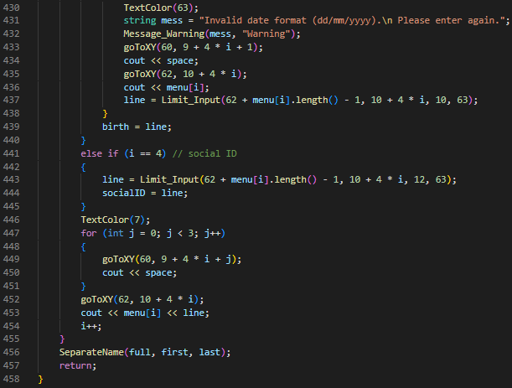

* File: [Year]_New_Year_Interface.cpp: stores functions with the purpose of getting back the file and having the user choose the year they want to create.
  + "Show_Year_List" prints out the lists of existing years.

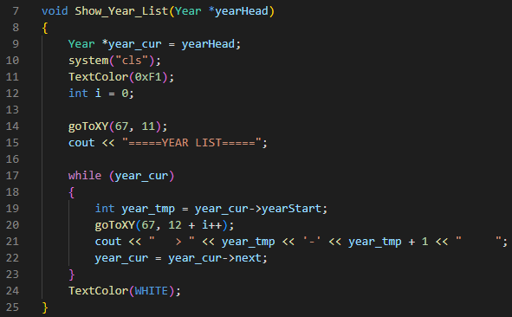

* + "Get_CheckFormat_Existed_Year" first calls 'Show_Year_List" function and allows the user to input the school year.

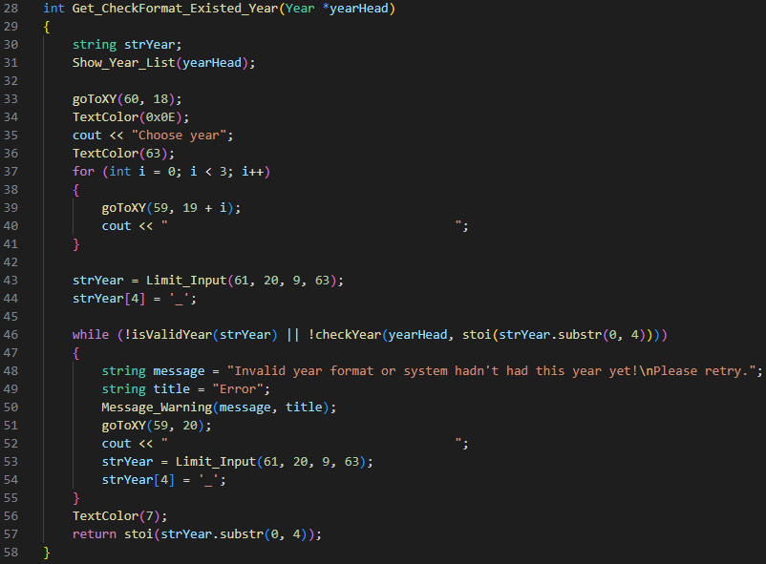

* + "RecoverFile" is called to begin loading all files that saved in files and create the first linked list of years.

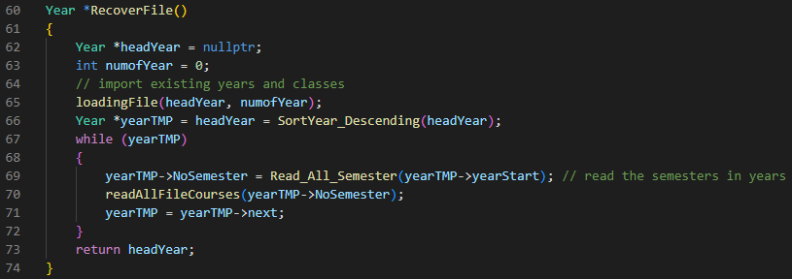

* + "Interface_New_Year" allows users to enter the year they want to create and call 'create_new_year' function to create the new year.

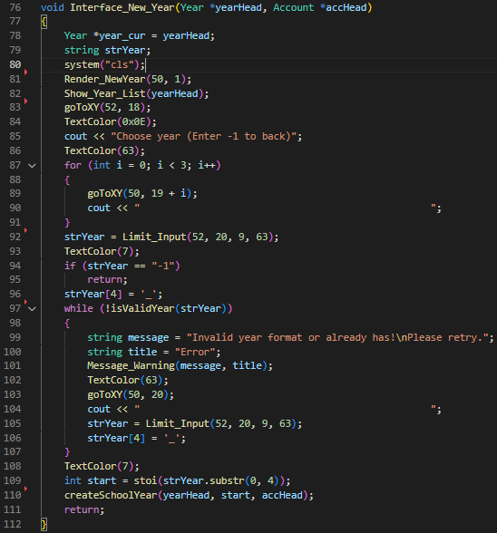

1. **[Help] Section**

* File: [Help]_CaculateAmount.cpp: This file contains functions to calculate the amount of number of elements in the linked list or calculate the GPA of.
* The “CaculateGPA_1_Student” function calculates the total score of all students, then divides it by the number of subjects studied by the student and returns the result.

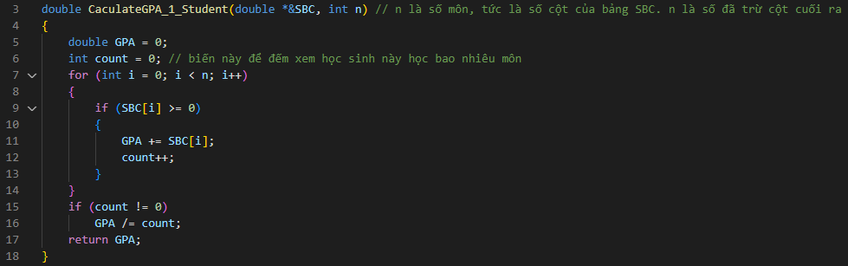

* The “amountClass” function to calculate the number of classes in the listed Class.

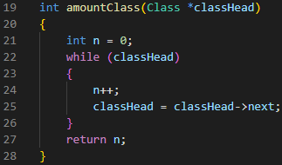

* The “amountCourseOfStudent” function to calculate the number of courses of a student or an all-student in class.

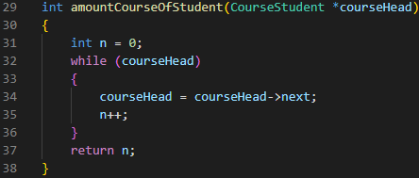

* The “amountStudentOfCourse” function calculates the number of course students.

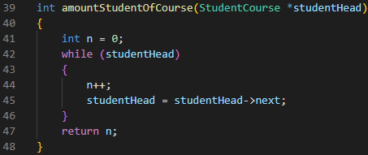

* The “amountStudentOfClass” function calculates the number of class students.

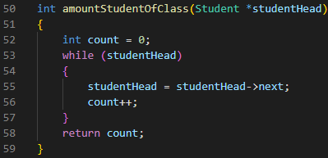

* File: [Help]_Check.cpp: This file contains the function to check the existence of a file or an element in a linked list and to check whether the value is valid or not.
* The “checkFile” function checks if the file exists or not, if yes, return true, return false.

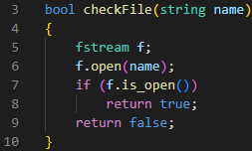

* The “isDouble” function checks if the number is of type double.

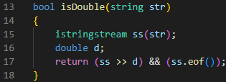

* The “checkExistence_OfCourse” function checks if the course in the list course of students exists or not, if yes, return Cours, return nullptr.

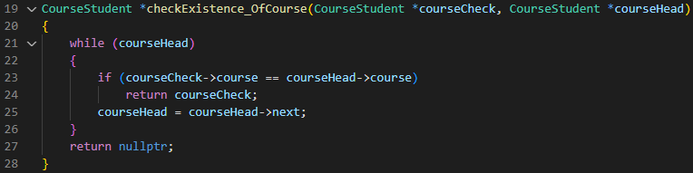

* File: [Help]_Choose.cpp: This file contains a function that displays choices and the user selects by pressing enter and returns the selected choices. The x and y variables are the coordinates to start showing this selection in all functions below.
* The “chooseYearbyOption_XY”: shows the years and the end of the selection list is a BACK selection. If the user selects a year, that year is returned, and if Back is selected, nullptr is returned.

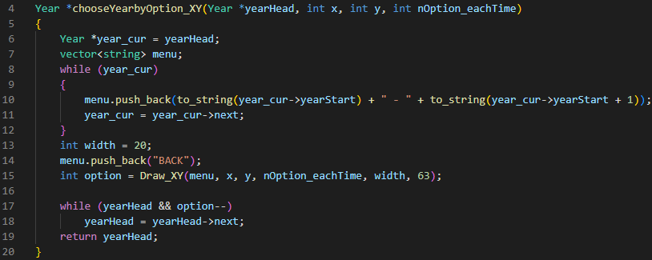

* The “chooseClassrbyOption_XY”: function shows the class in the year and the end of the selection list is a back selection. If the user selects a class, that class is returned, and if Back is selected, nullptr is returned.

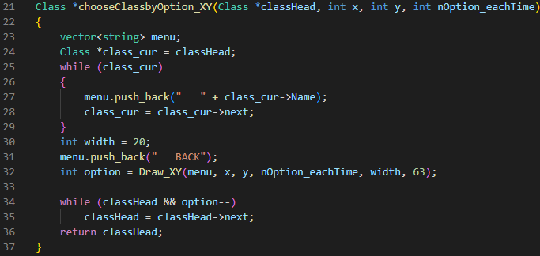

* The “chooseClass_inAllYear_byOption_XY” function same as the “chooseClassrbyOption_XY” function but it shows all classes in the information system.

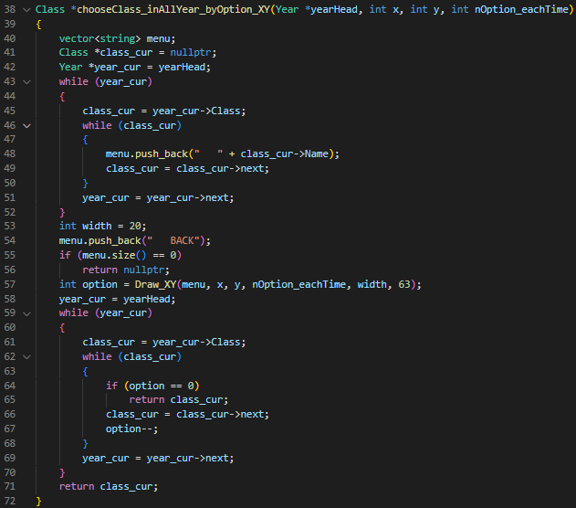

* The “chooseSemesterbyOption_XY”: function shows the Semesters in the year and the end of the selection list is a Back selection. If the user selects any Semester, that Semester is returned, and if Back is selected, nullptr is returned.

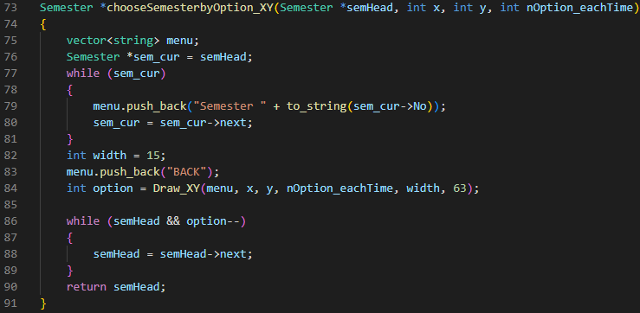

* The “chooseCoursebyOption_XY”: function shows the Courses and the end of the selection list is a Back selection. If the user selects any Course, that Course is returned, and if Back is selected, nullptr is returned.

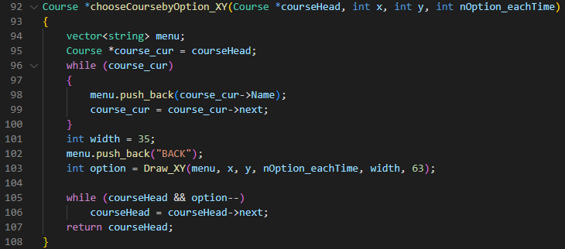

* The “ChooseStudentOfClass” function displays a table containing three columns: No, ID, and Name. if the user selects a cell then the student of that row will be selected and if the user press ESC then return.

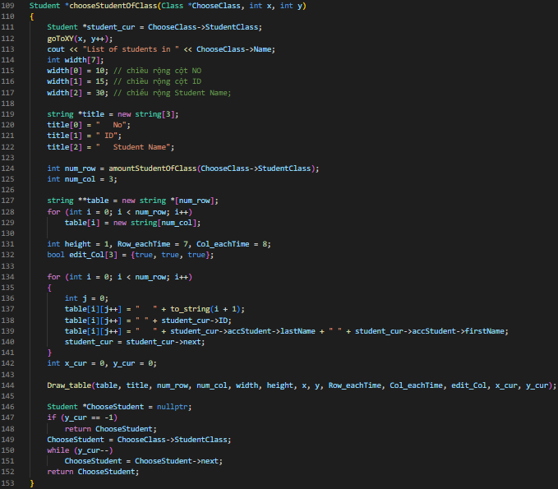

* File:[Help]_Create.cpp: This file contains the function to create a name, a linked list, or a table as a two-dimensional array. Moreover, this file also includes a function to get the first character in a string or format a Mark.
* The "FormatMark" function converts scores from numbers to strings. if the score is valid, then switch, if not, then change to X.

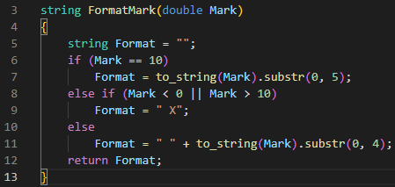

* The "getFirstChar" function takes the first character of each word in a string and concatenates it into a string and returns that string.

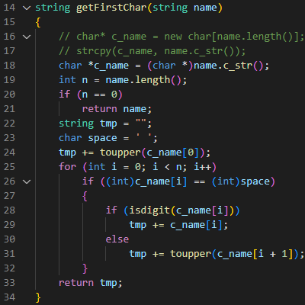

* The “createNameFile” function "generates a path to a given file by directory name, subdirectory, filename, and file type.

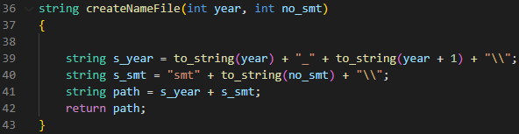

* The “CreateSB_ofStudent_inClass” function imports the final marks of a student's course into the transcript.

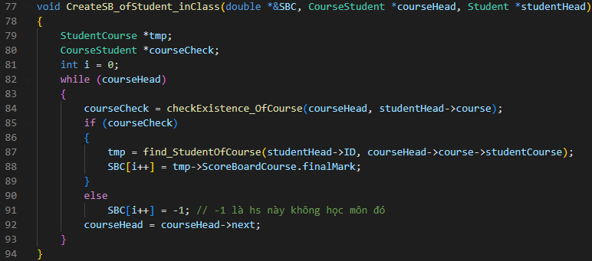

* The “createSBC_ofClass” function imports the final marks of all students’ courses into the transcript and calculates the GPA of all students.

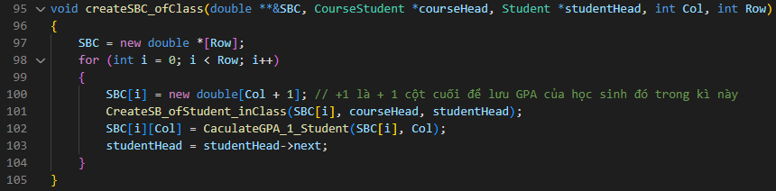

* File: [Help]_Find.cpp: This file contains functions to search for an element on request, if not found returns nullptr.
* The “findStudentbyID” function will find the student in the system, if found then return the student, and if not found then return nullptr.

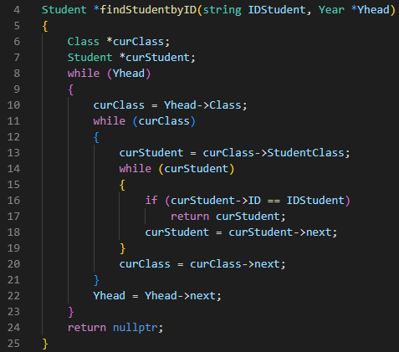

* The “find_StudentOfCOurse” function will find the Course’s Student with Student’s ID, if yes, return that student, otherwise return nullptr.

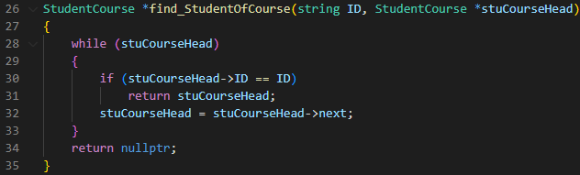

1. **[Course] Section**

* File: [Course]_Interface.cpp This file includes functions that display choices so the user can choose the functionality they want, such as viewing the list course in class.
* The “Interface_ViewScoreBoardCourse” function will let the user choose the year, then select the semester in that year, and finally select the subject in that semester to display the scoreboard.

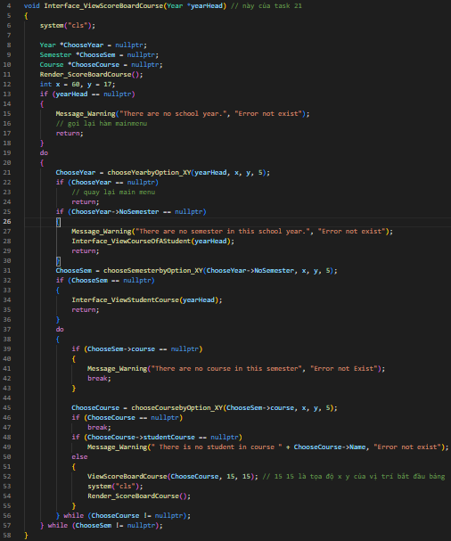

* The “Interface_ViewStudentCourse” function allows users to choose like the function above, but after selecting, it will display a list of students in the course.

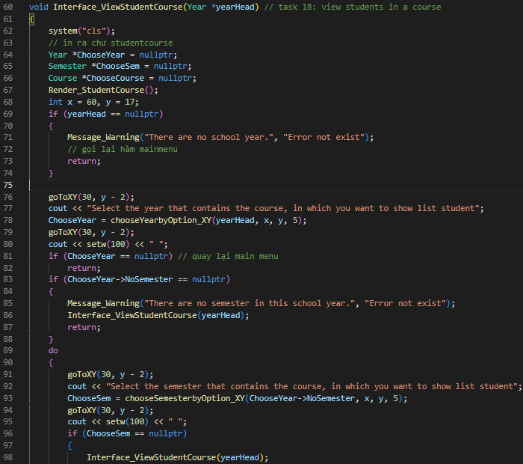

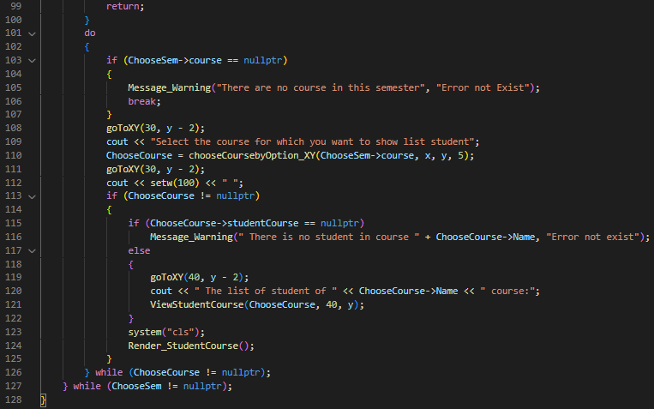

* The “Interface_ViewCourseOfAStudent” function will let the user choose a class in the list of classes, then select a student in that class to display the list course of that student.

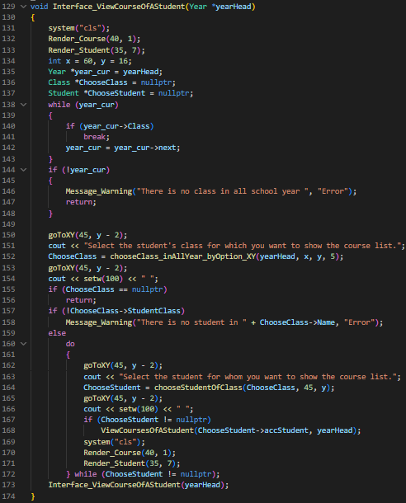

* File: [Course]_Menu: This file includes functions that display menus so the user can choose the functionality they want, such as updating or viewing the list course in class.
* The “Menu_Staff_View” function display choices that staff can view and select, including a list scoreboard, a list student, a list class, and a list course.

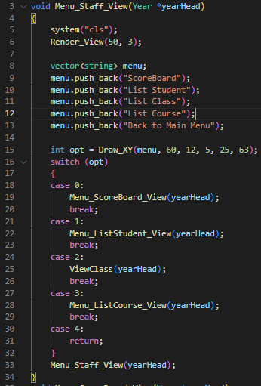

* The “Menu_ScoreBoard_View” function allows the user to choose one of three choices, including viewing the scoreboard of all class students, viewing the scoreboard of all course students, or back to Menu Staff View.

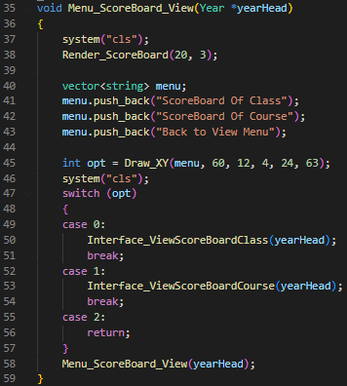

* The “Menu_ListStudent_View” function allows the user to choose one of three choices, including viewing all class students, viewing all course students, or back to Menu Staff View.

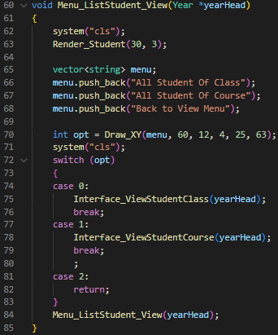

* The “Menu_Listcourse_View” function also has three options, viewing courses of each year's school, viewing all courses in a semester, or back to Menu Staff View.

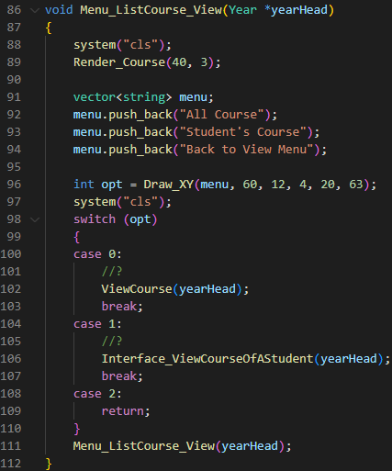

* The “Menu_Import_Export” function also has three options, import the scoreboard of a course, export the list of students in a course, or back to Menu Staff View.

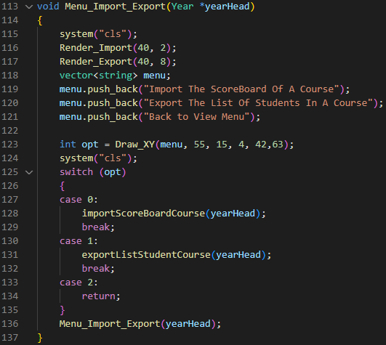

* File [Course]_Update.cpp: This file contains functions to modify the scoreboard of a student if it has any mistakes or enter the score into the scoreboard.
* The “updateSBC” function will display the scoreboard of a course, then it allows the user to choose the cell which wants to update by pressing enter and entering a new score. Also, if the user press ESC, then finish the function.

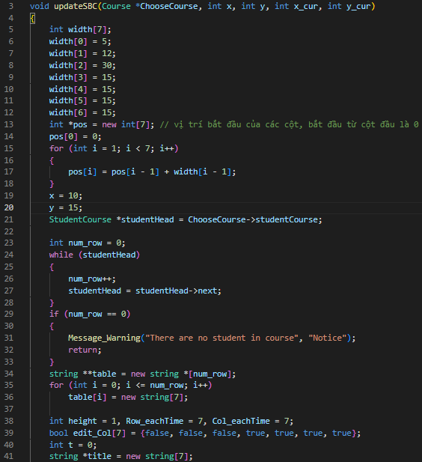

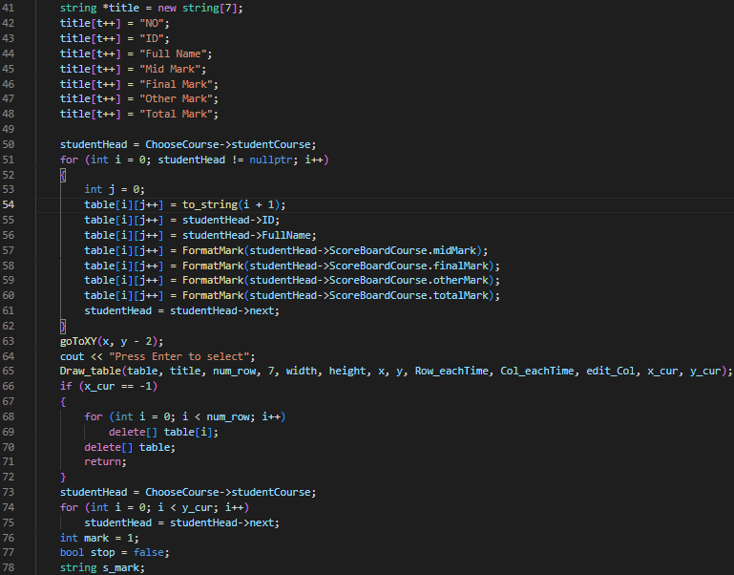

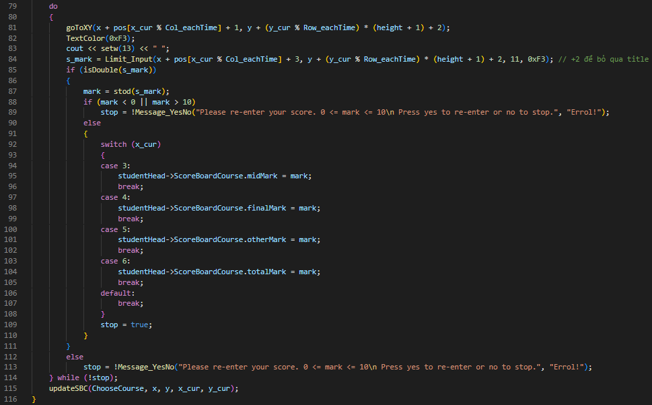

* The “UpdateStudentResult” function allows the user to choose the course, that the user wants to update in the current semester. Then, it will call the updateSBC function.

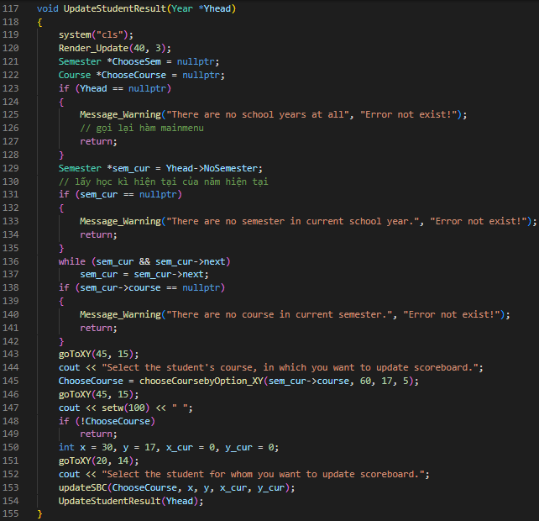

* File: [Course]_View.cpp: This file contains functions that allow the user to choose a choice in the list of the choice and then display it on screen.
* The “ViewStudentCourse” displays a table containing the list of students in a course with three columns: No, ID, and Student’s Name.

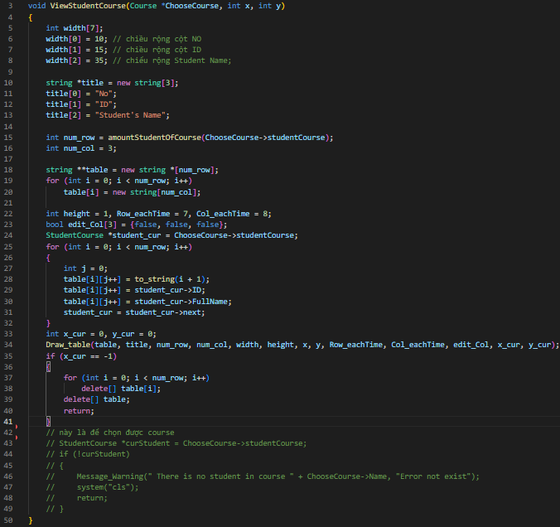

* The “ViewScoreBoardCourse” function displays a table containing the list of students’ information and student scoreboard in a course with seven columns: No, ID, Student’s Name, MidMark, FinalMark, OtherMark, and TotalMark.

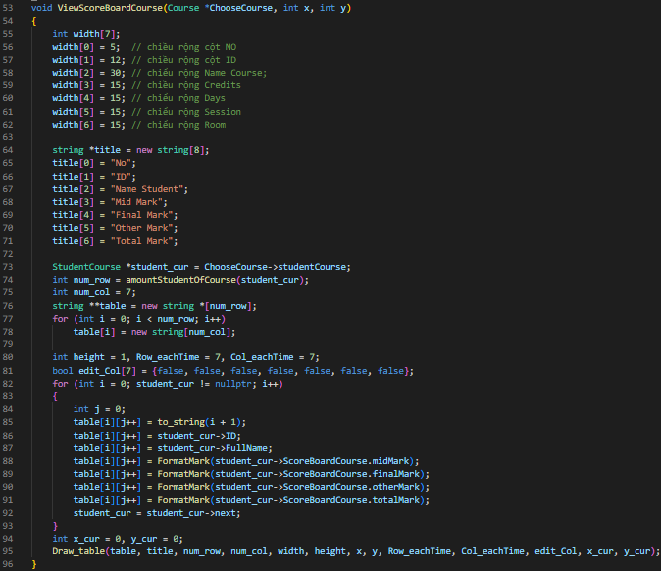

* The “ViewCourseOfAStudent” function displays a table containing the list of courses’ information in a semester with columns: No, ID, Course’s Name, Credits, Day, Session, Room, and Teacher Name.

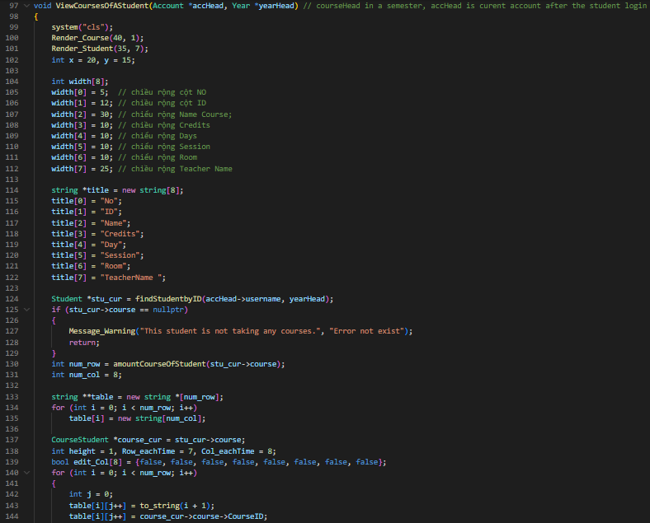

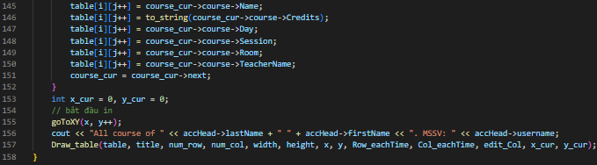

1. **[Class] Section**

* File: [Class]_Interface.cpp
* The “Interface_ViewScoreBoardClass” function will let the user choose a class in the system, then select the year, and finally select the semester in that year to display all students’ scoreboards of each course.

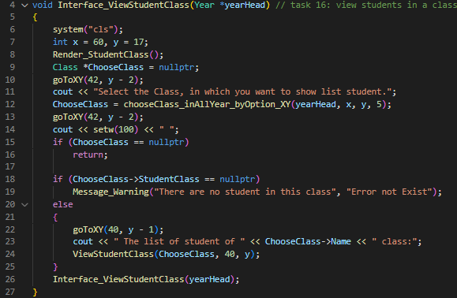

* The “Interface_ViewStudentClass” function allows users to choose a class in the system, and then it will display a list of students in the class.

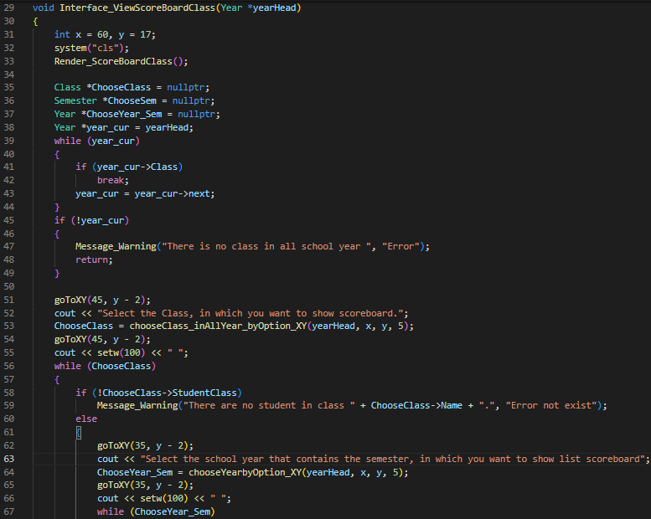

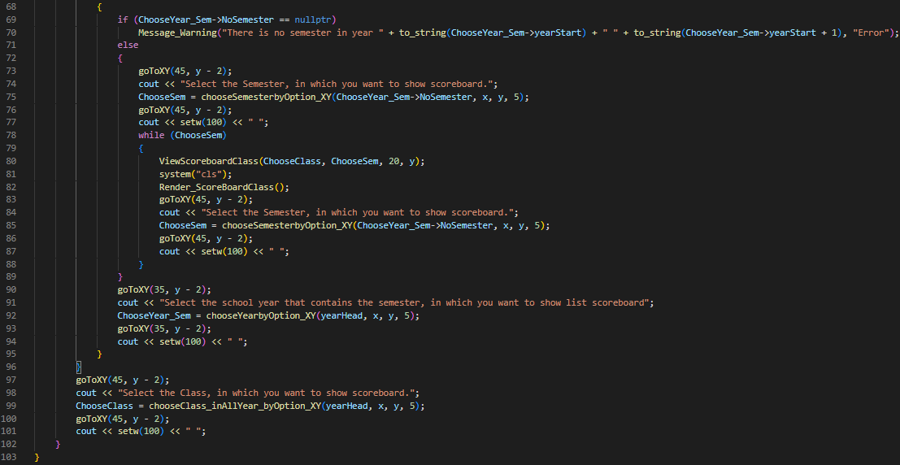

* File: [Class]_View.cpp: This file contains functions that allow the user to choose a choice in the list of the choice and then display it on screen.
* The “ViewStudentClass” displays a table containing the list of students in a class with three columns: No, ID, and Student’s Name.

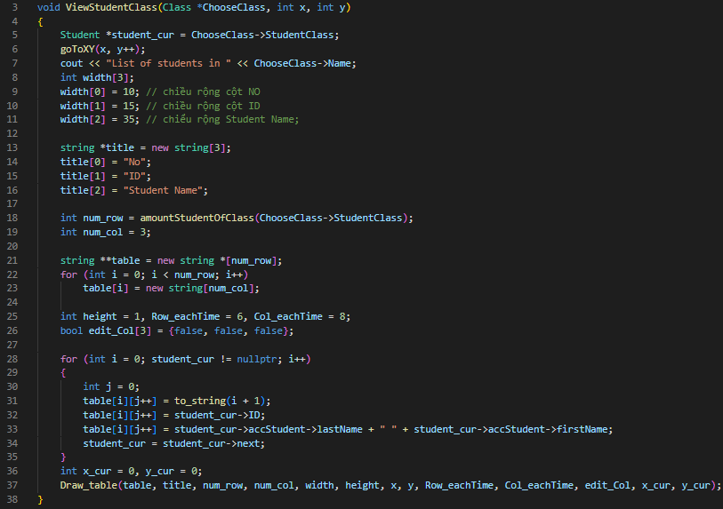

* The “ViewScoreBoardClass” function displays a table containing the list of students’ information and student scoreboard in a class with eight columns: No, ID, Cousre’s Name, MidMark, FinalMark, OtherMark, TotalMark, and GPA.

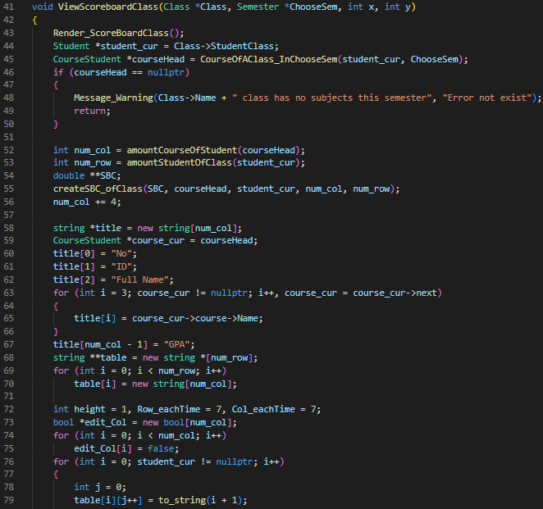

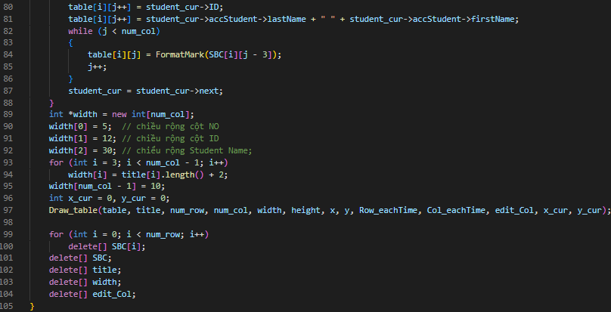

* The “ViewClass” function displays a table containing the list of class information in a year, that uses selected with two columns: No, Class Name.

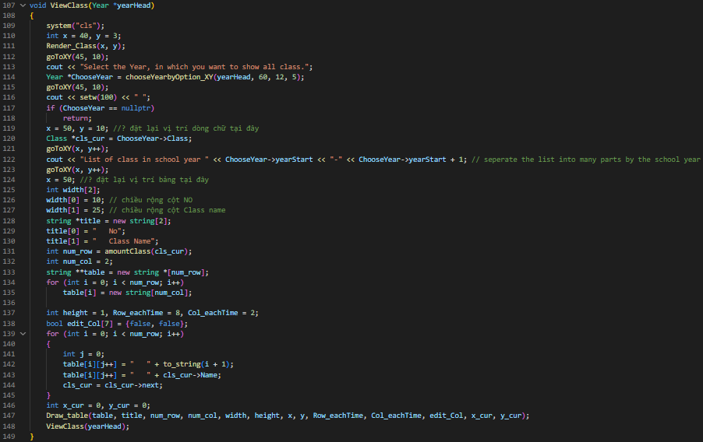

1. **[Student] Section**

* File [Student]_Interface.cpp: This file contains student functions that allow the student to choose a choice in the list of the choice and then display it on screen.
* The “Interface_ViewCoursesOfUser” function will allow the user to choose a year school or back to the student main menu, then select a semester in that year, and finish it will display all the courses in the semester.

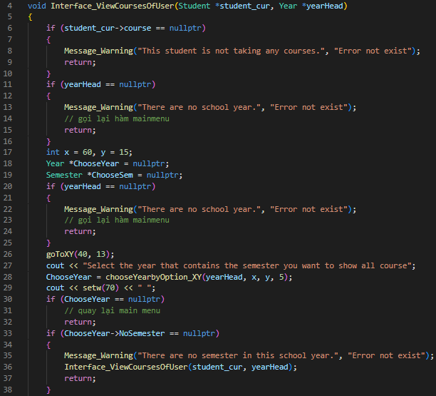

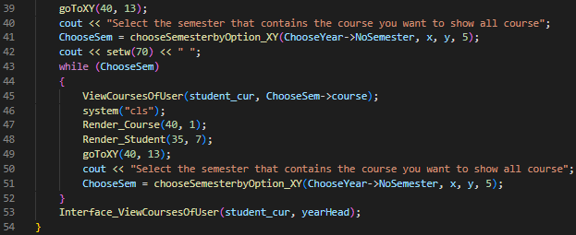

* The “Interface_ViewScoreBoardOfUser” function will allow the user to choose a year school or back to the student main menu, then select a semester in that year, and finish it will display the scoreboard of that student in all the courses of the semester.

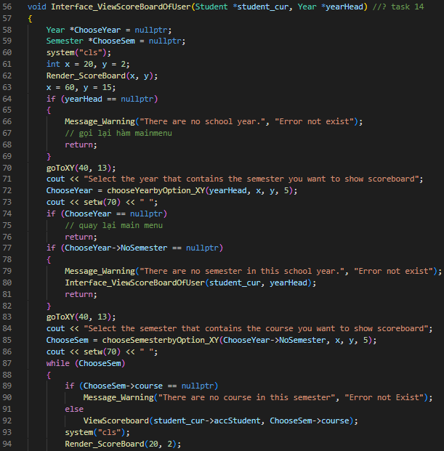

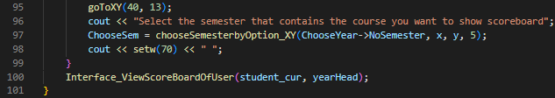

* File: [Students]_View.cpp: This file contains view functions that allow the user to choose a choice in the list of the choice and then display it on screen.
* The “ViewCourseOfUser” function displays a table containing the list of courses’ information in a semester with columns: No, ID, Course’s Name, Credits, Day, Session, Room, and Teacher Name.

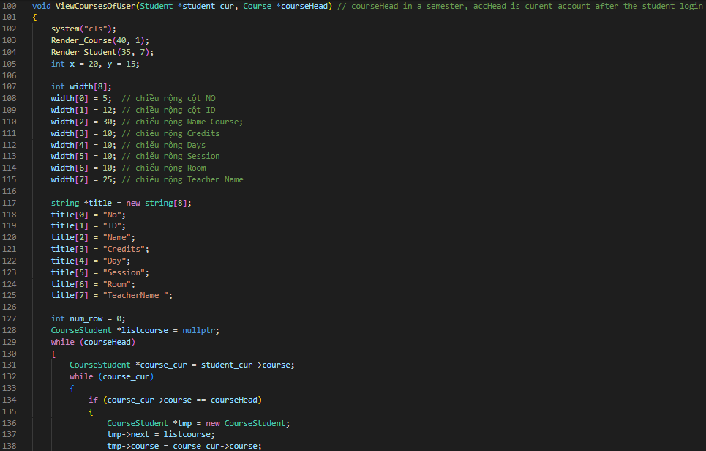

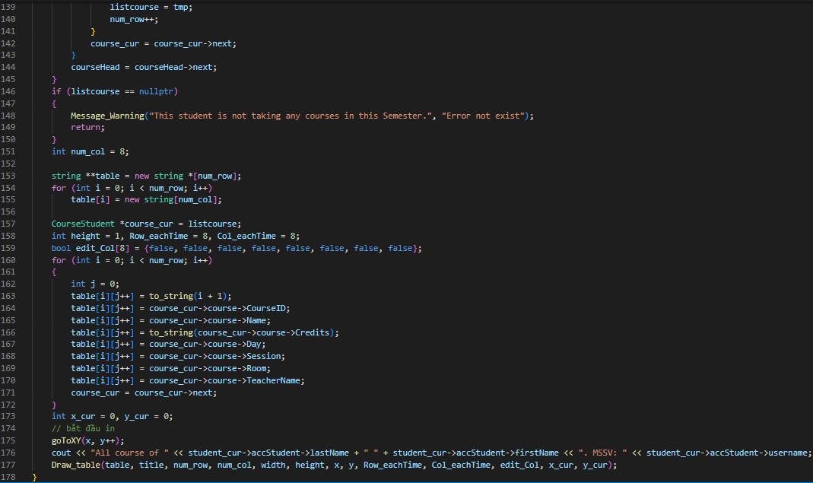

* The “ViewScoreBoard” function displays a table containing the list of students’ information and student scoreboard in a course with seven columns: No, ID, Course’s Name, MidMark, FinalMark, OtherMark, and TotalMark.

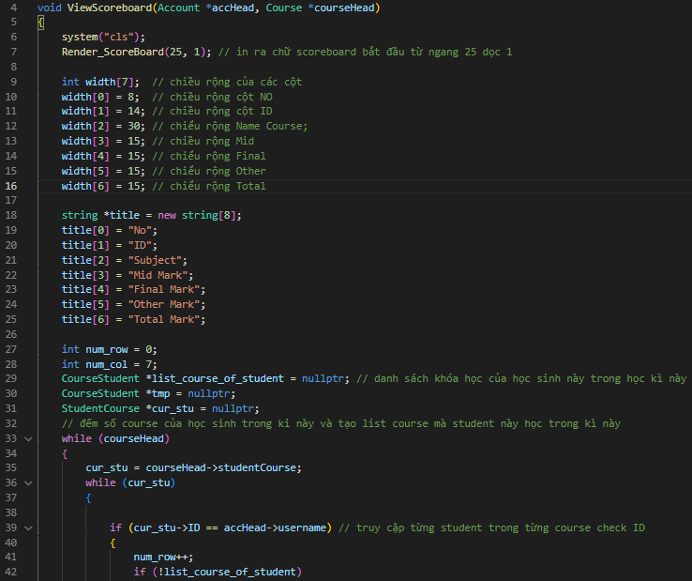

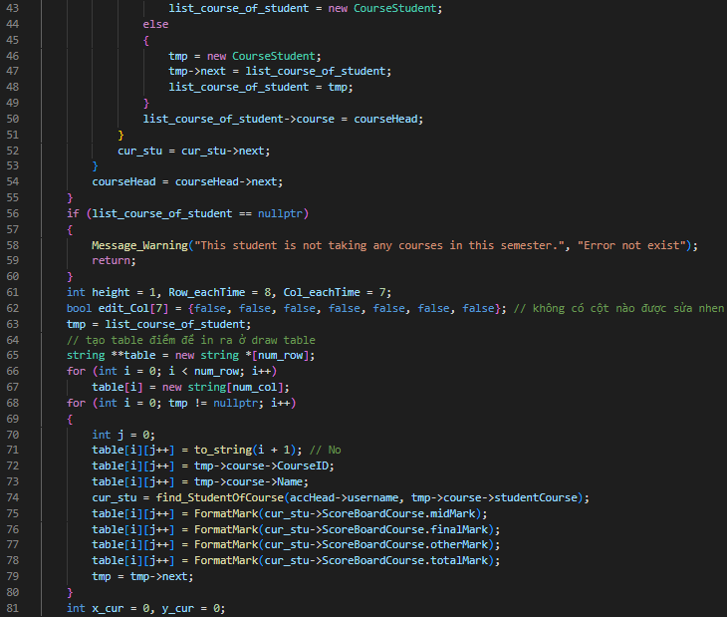

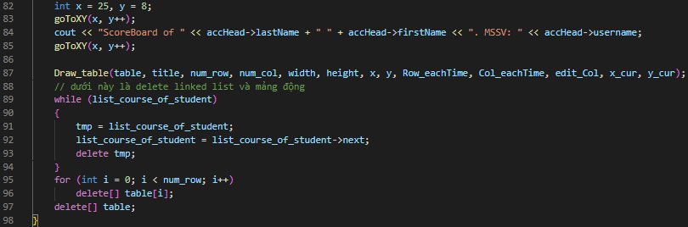

1. **Login.cpp**

* "LoggingIn" prints out the boxes for users to enter the username and password and checks through the account linked list to verify it to allow users to access in the program.

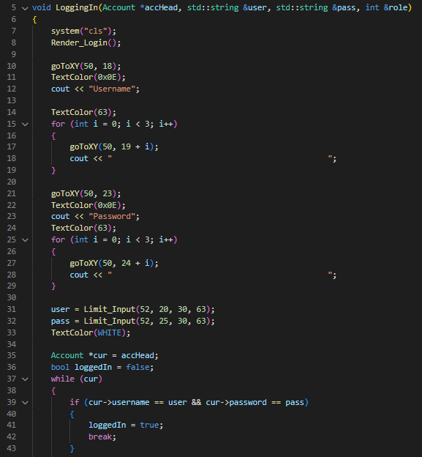

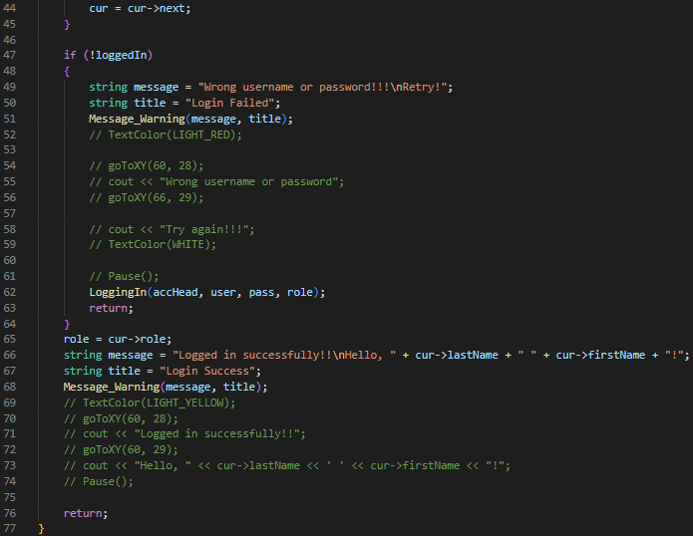

* "ChangePass" makes users re-enter their password to change into the new one and save it into the data bank.

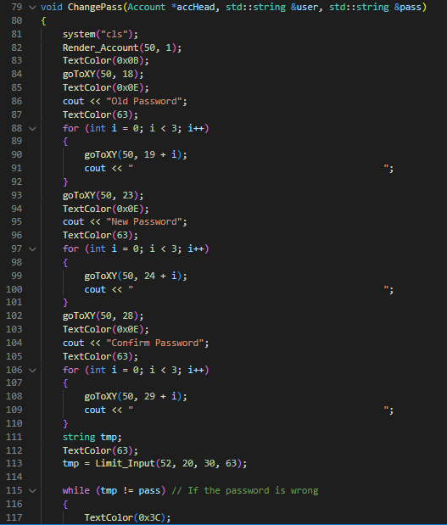

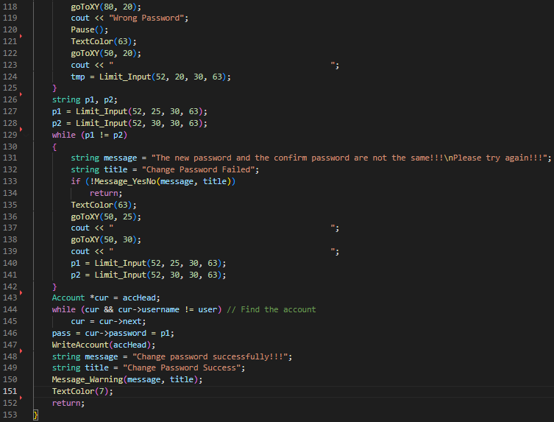

* "Profiling" displays the user's profile including username, password, role, full name, birthday, gender, and social ID.

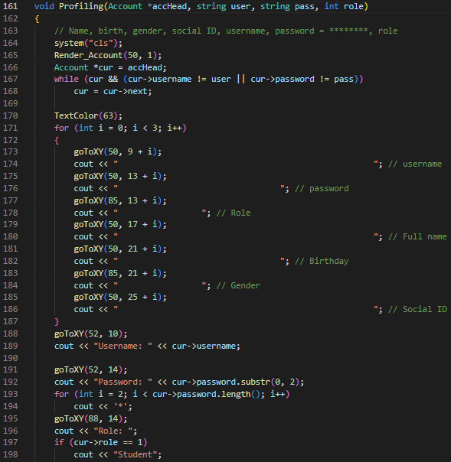

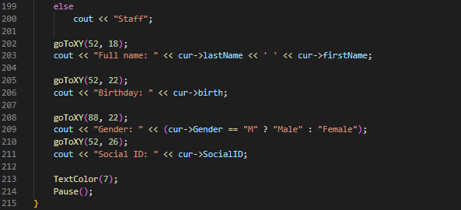

* "AccountAlteration" prints out the menu of managing accounts and calls the corresponding functions to do the tasks.

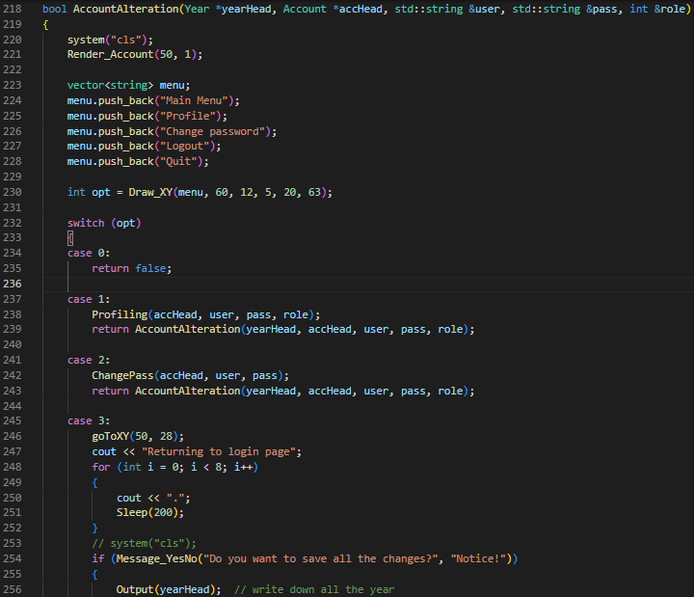

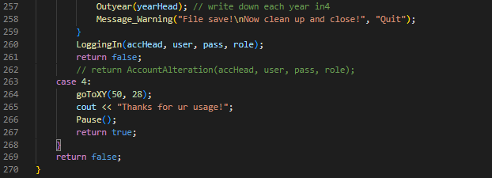

* "LoggingMain" stores the two functions to minimize the calling function in the other functions to login and manage accounts.

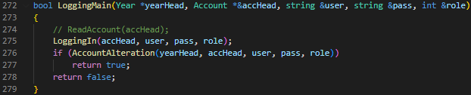

1. **Main.cpp**

* "EradicateLL" is managed to call all functions that delete the linked list and free up the memory.

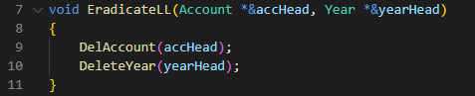

* "Merge_year_sem" merges all the tasks including recover back the files, reading the accounts and years, linking the information around the linked lists, and calling the main menu that fits the user's role.

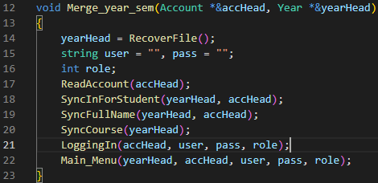

1. **Summary**

In conclusion, the university management software is a comprehensive solution for managing various aspects of a university, including students, courses, and semesters. The software is designed to provide ease of use, scalability, and flexibility to accommodate the ever-changing needs of a university.

With the help of this software, university administrators can easily manage student enrollment, track course attendance, manage student records, and generate various reports. Additionally, the software provides a user-friendly interface for students to register for courses, view their schedules, and access course materials.

Furthermore, the software is designed to be modular and easily extendable, allowing for the addition of new features and integration with other systems as required. The software has been developed using industry-standard programming languages and technologies, ensuring its reliability and security.

Overall, the university management software provides an all-in-one solution for managing a university, helping to streamline administrative processes and improve student outcomes. The software is an essential tool for any university looking to improve its management systems and stay competitive in the ever-evolving education industry.

**END**